Supporting Information
Mobile Phone Radiofrequency Exposure and Tumor Risk: An Umbrella Review of Exposure Duration and Laterality
Short title: Mobile Phone Exposure and Tumor Risk
Seulgi Yoon^{a*}, Jimin Choi^{a*}, Hyun-Joo Kim^{b,c}, PhD, Chaeseong Lim^{d}, MD, Dokyoung Kim^{e}, PhD, Su-Yeon Cho^{f,g}, Yujin Kwon^{h}, Eun-Soo Lee^{i,j}, MD, PhD, Jin Suh Yu^{k,l}, Won Kyu Kim^{f,g,h†}, PhD, Yun Hak Kim^{l,m†}, MD, PhD, Kihun Kim^{i,j†}, MD, PhD
ªDepartment of Medicine, Korea University College of Medicine, Seoul 02841, Republic of Korea
^{b}Department of Periodontology, Dental and Life Science Institute, School of Dentistry, Pusan National University, Yangsan 50612, Republic of Korea
^{c}Department of Periodontics and Dental Research Institute, Pusan National University Dental Hospital, Yangsan 50612, Republic of Korea
^{d}Department of Internal Medicine, Gachon University Gil Hospital, Incheon 21565, Republic of Korea
^{e}Department of Anatomy and Neurobiology, College of Medicine, Kyung Hee University, Seoul 02447, Republic of Korea
^{f}Natural Product Research Center, Korea Institute of Science and Technology, Gangneung 25451, Republic of Korea
^{g}Natural Product Applied Science, KIST School, University of Science and Technology (UST), Gangneung 25451, Republic of Korea
^{h}Department of Convergence Medicine, Yonsei University Wonju College of Medicine, Wonju 26426, Republic of Korea
^{i}Department of Occupational and Environmental Medicine, Pusan National University Yangsan Hospital, Yangsan 50612, Republic of Korea
^{j}Research Institute for Convergence of Biomedical Science and Technology, Pusan National University Yangsan Hospital, Yangsan 50612, Republic of Korea
^{k}Convergence Medical Sciences, Pusan National University, Yangsan 50612, Republic of Korea
^{l}Department of Biomedical Informatics, School of Medicine, Pusan National University, Yangsan 50612, Republic of Korea
^{m}Department of Anatomy, School of Medicine, Pusan National University, Yangsan 50612, Republic of Korea
*These authors contributed equally to this work as first authors

Corresponding authors
Won Kyu Kim, Ph.D.
Natural Product Research Center, Korea Institute of Science and Technology (KIST), Gangneung, Republic of Korea, 25451
Division of Natural Products Applied Science, University of Science and Technology (UST), Daejeon, Republic of Korea, 34113
Department of Convergence Medicine, Yonsei University Wonju College of Medicine, Wonju, Republic of Korea, 26426
Tel: +82-33-650-3416
Fax: +82-33-650-3419
E-mail: wkkim@kist.re.kr

Yun Hak Kim, M.D., Ph.D.
Department of Anatomy and Department of Biomedical Informatics, Pusan National University, 49 Busandaehak-ro, Yangsan 50612, Republic of Korea
Tel: +82-51-510-8091
Fax: +82-51-510-8049
E-mail: yunhak10510@pusan.ac.kr

Kihun Kim, M.D., Ph.D.
Department of Occupational and Environmental Medicine, Pusan National University Yangsan Hospital, Yangsan, Republic of Korea, 50612
Tel: +82-55-360-2142
Fax: +82-55-360-2172
E-mail: kihun7603@pnuyh.co.kr

Supplementary Table 1. Final search strategy for each database
Database | Search strategy
Medline and Embase | ('cell phone':ab,ti OR 'cell phones':ab,ti OR cellphone:ab,ti OR cellphones:ab,ti OR 'cellular phone':ab,ti OR 'cellular phones':ab,ti OR 'cellular telephone':ab,ti OR 'cellular telephones':ab,ti OR 'mobile phone':ab,ti OR 'mobile phones':ab,ti OR 'mobile telephone':ab,ti OR 'mobile telephones':ab,ti OR smartphone:ab,ti OR smartphones:ab,ti OR 'smart phone':ab,ti OR 'smart phones':ab,ti)  AND  ('systematic review':ab,ti OR 'meta analysis':ab,ti)  AND  [humans]/lim
Web of Science | (TI=(cell phone) OR AB=(cell phone) OR TI=(cell phones) OR AB=(cell phones) OR TI=(cellphone) OR AB=(cellphone) OR TI=(cellphones) OR AB=(cellphones) OR TI=(cellular phone) OR AB=(cellular phone) OR TI=(cellular phones) OR AB=(cellular phones) OR TI=(cellular telephone) OR AB=(cellular telephone) OR TI=(cellular telephones) OR AB=(cellular telephones) OR TI=(mobile phone) OR AB=(mobile phone) OR TI=(mobile phones) OR AB=(mobile phones) OR TI=(mobile telephone) OR AB=(mobile telephone) OR TI=(mobile telephones) OR AB=(mobile telephones) OR TI=(smartphone) OR AB=(smartphone) OR TI=(smartphones) OR AB=(smartphones) OR TI=(smart phone) OR AB=(smart phone) OR TI=(smart phones) OR AB=(smart phones))  AND  (TI=(systematic review) OR AB=(systematic review) OR TI=(meta-analysis) OR AB=(meta-analysis))
Scopus | TITLE-ABS-KEY(cell phone) OR TITLE-ABS-KEY(cell phones) OR TITLE-ABS-KEY(cellphone) OR TITLE-ABS-KEY(cellphones) OR TITLE-ABS-KEY(cellular phone) OR TITLE-ABS-KEY(cellular phones) OR TITLE-ABS-KEY(mobile phone) OR TITLE-ABS-KEY(mobile phones) OR TITLE-ABS-KEY(mobile telephone) OR TITLE-ABS-KEY(mobile telephones) OR TITLE-ABS-KEY(smartphone) OR TITLE-ABS-KEY(smartphones) OR TITLE-ABS-KEY(smart phone) OR TITLE-ABS-KEY(smart phones)  AND  TITLE-ABS-KEY(systematic review) OR TITLE-ABS-KEY(meta-analysis)
ScienceDirect | Title, abstract or author-specified keywords  (cell phone OR cellphone OR cellular phone OR cellular telephone OR mobilephone OR smartphone)  AND  (systematic review OR meta-analysis)

Supplementary Table 2. Certainty of Evidence Assessment Using a GRADE-Informed Scoring Framework
Criteria | Descriptions
Risk of Bias | Based on AMSTAR 2 ratings. Reviews rated as low or critically low quality were downgraded by −1 point (high risk of bias). Reviews rated as moderate quality were downgraded by −0.5 point (some concerns). Reviews rated as high quality were not downgraded. AMSTAR 2 was applied to all reviews; earlier publications may have been disadvantaged by evolving reporting standards (e.g., protocol registration or ROB2 assessment).
Inconsistency | Assessed using I² statistics and heterogeneity P-values. I² ≥50% or P <0.001 indicated serious inconsistency (−1 point). I² 25–49% or P <0.05 indicated some concerns (−0.5 point). I² ≤25% or P ≥0.05 indicated no serious inconsistency (no downgrade). When I² was not reported, it was calculated from Cochran’s Q statistic. If neither I² nor P-value was available, inconsistency was rated as uncertain with no downgrade.
Indirectness | Evidence was downgraded by −1 point when the population, exposure, comparator, or outcome did not directly correspond to the review question; otherwise, no downgrade was applied.
Imprecision | Evidence was downgraded by −1 point if the 95% confidence interval included the null value (e.g., OR or RR = 1.0), indicating uncertainty in the direction of the effect.
Publication Bias | Evidence was downgraded by −1 point when Egger’s regression test indicated small-study effects (P <0.05). If Egger’s test was not performed or not reported, publication bias was rated as uncertain with no downgrade.
Dose-response relationship | Evidence was upgraded by +1 point when a statistically supported dose–response relationship was demonstrated through dose–response meta-analysis, meta-regression, or a significant monotonic trend across predefined exposure categories (e.g., increasing risk with longer duration of mobile phone use).
Plausible confounding factors | Evidence was upgraded by +1 point when all plausible residual confounding was judged likely to attenuate, rather than exaggerate, the observed association (i.e., bias toward the null).
Strength of association | Evidence was upgraded by +1 point when a large magnitude of effect was observed (pooled OR or RR ≥2.0 or ≤0.5), provided that no serious risk of bias or major inconsistency was present.
Additional rules | Baseline certainty for all outcomes was set to low (score = 0), as all included studies were observational meta-analyses.  A maximum of one upgrading (+1 point) was allowed per outcome.  Partial downgrades (−0.5) were conservatively rounded to −1, and partial upgrades were not accumulated.  When key information required for a domain was unavailable, the domain was rated as uncertain and not downgraded.
Scoring Rules | The final certainty levels were defined as: High (total score ≥ 2), Moderate (1), Low (0), Very Low (≤ −1).
Supplementary Table 3. Evidence Classification Criteria
Evidence Class | Descriptions*
Class I: convincing evidence | >1000 cases (or >20 000 participants for continuous outcomes); statistical significance at P <10⁻⁶ (random  effects); no evidence of small study effects and excess significance bias; 95% prediction interval excluded null  value; no large heterogeneity (I² <50%)
Class II: highly suggestive evidence | >1000 cases (or >20 000 participants for continuous outcomes), statistical significance at P <10⁻⁶
Class III: suggestive evidence | >1000 cases (or >20 000 participants for continuous outcomes) and statistical significance at P <0.001
Class IV: weak evidence | Remaining significant associations with P <0.05
NS: non-significant | P >0.05
* For meta-analyses that did not report exact P-values, P-values were estimated from the reported effect sizes and 95% confidence intervals using standard normal Z-statistics. The standard error (SE) of the log-transformed effect estimate was calculated as:SE = [log(Upper CI) − log(Lower CI)] / (2 × 1.96). The Z-statistic was then computed as: Z = log(Effect estimate) / SE. Two-sided P-values were derived from the standard normal distribution: P = 2 × (1 − Φ(|Z|)). where Φ denotes the cumulative distribution function of the standard normal distribution. These estimated P-values were used exclusively for the purpose of evidence class assignment and did not influence pooled effect estimates or GRADE certainty ratings.

Supplementary Table 4. Characteristics of included studies
Study (year) | Included study designs | Exposure source | Exposure definition | Latency categories | Subgroup domains | Outcomes assessed | AMSTAR grade
Repacholi et al. (2011) | Cohort; case-control | Wireless phones (mobile and cordless phones) | Ever use; duration-based use | Long-term use (≥10 years) | Exposure duration; laterality | Glioma; meningioma; acoustic neuroma; parotid gland tumors | High
Bortkiewicz et al. (2017) | Case-control | Mobile phones (analogue, digital) | Regular use; duration-based use; phone type-specific use | ≥10 years of use or since first regular use | Exposure duration; phone type; laterality | Intracranial tumors; glioma; meningioma; acoustic neuroma; salivary gland tumors | High
Prasad et al. (2017) | Case-control (meta-analysis); cohort (systematic review only) | Mobile phones | Ever use; long-term use (≥10 years or ≥1640 h) | Long-term use (≥10 years or ≥1640 h) | Study quality; funding source; exposure duration | Brain tumors; glioma; meningioma; acoustic neuroma | High
Yang et al. (2017) | Case-control | Mobile phones | Any use; long-term use; laterality-based use | Long-term use (≥10 years) | Exposure duration; laterality; glioma grade | Glioma; low-grade glioma; high-grade glioma | High
Choi et al. (2020) | Case-control | cellular phone or mobile phone | Regular vs non-regular use; cumulative or lifetime use; cumulative call time; cumulative number of calls | Time since the start of mobile phone use (<5, 5–9, ≥10 years) | Response rates; use of blinding at interview for ascertainment of exposure; methodological quality; funding sources; type of case-control study; latency; cumulative or lifetime use; cumulative call time; cumulative number of calls; tumor malignancy | Brain tumors; head and neck tumors (including parotid gland); other solid and hematologic tumors | High
Karipidis et al. (2024) | Cohort; case-control | Mobile phones; cordless phones (near-field RF) | Ever/regular use; time since the start of mobile phone use; cumulative call time; cumulative number of calls | Time since the start of mobile phone use/exposure (<5, 5–9, ≥10 years) | Exposure duration; exposure source; age group; risk-of-bias tier | Glioma; brain cancer; meningioma; acoustic neuroma; pituitary tumors; salivary gland tumors | High
Karipidis et al. (2025) | Cohort; case-control | Wireless phone; mobile phone; occupational RF-EMF exposure; fixed-site transmitters | RF-EMF exposure from mobile phones: (ever or regular use vs never or non-regular use); occupational RF-EMF exposure: exposed vs unexposed | Time since first use/exposure (<5, 5–9, ≥10 years) | Exposure duration; exposure source; study design | Leukemia; non-Hodgkin’s lymphoma; thyroid cancer; lymphohematopoietic system tumors; oral cavity/pharynx cancer | High
Myung et al. (2009) | Case-control | Mobile phones (including cordless phones) | Ever vs never use; duration-based use; long-term use | Long-term use (≥10 years) | Study quality; research group; phone type; laterality; tumor malignancy/type | Brain tumors; glioma; meningioma; acoustic neuroma; other tumors | Moderate
Wang et al. (2016) | Cohort; case-control | Mobile phones | Use vs non-use; duration-based use | Duration of use (≥1 year; >5 years) | Exposure duration | Glioma | Moderate
Chen et al. (2021) | Cohort; case-control | Mobile phones; cordless phones | Ever/regular use; time since the start of mobile phone use | Time since the start of mobile phone use (<5, 5–10, >10 years) | Time since the start of mobile phone use; laterality | Adult meningioma | Moderate
Cao et al. (2022) | Cohort; case-control; cross-sectional | Mobile phones | Use vs non-use; long-term use | Long-term vs short-term use (study-specific) | Exposure duration; country; age group | Neoplasms (including brain tumors, glioma, thyroid cancer) | Moderate
Hardell et al. (2008) | Case-control | Mobile phones; cordless phones | Use vs non-use; long-term use; laterality-based use | Latency (≥10 years) | Latency; laterality; tumor type | Glioma; acoustic neuroma; meningioma | Low
Khurana et al. (2009) | Case-control | Mobile phones; cordless phones | Long-term use (≥10 years); laterality-based use | Latency period ≥10 years | Latency; laterality; tumor type | Glioma; acoustic neuroma; meningioma | Low
Hardell et al. (2013) | Case-control | Mobile phones; cordless phones | Ever/regular use; cumulative call time; laterality-based use | Time since the start of mobile phone use (>1–5, >5–10, ≥10 years) | Cumulative exposure; laterality; tumor histology | Glioma; acoustic neuroma; meningioma | Low
Gong et al. (2014) | Case-control | Mobile phones | Use vs non-use; long-term use (≥10 years) | Long-term use (≥10 years) | Exposure duration; glioma grade | Glioma | Low
Lagorio et al. (2014) | Cohort; case-control | Mobile phones | Ever vs never use; time since start of use | Time since the start of mobile phone use (short-, medium-, long-term) | Study group; time since start use; study design | Glioma; meningioma; acoustic neuroma | Low
de Siqueira et al. (2017) | Case-control | Mobile phones | Use vs non-use | Not categorized | Not performed | Parotid gland tumors (benign and malignant) | Low
Moon et al. (2024) | Cohort; case-control | Mobile phones | Regular vs non-regular use; cumulative hours; laterality-based use | Years of use (>10 vs <10 years); cumulative hours (>896 h) | Exposure proxy; tumor type; study design; research group | Brain tumors (glioma; meningioma; acoustic neuroma; pituitary tumors) | Low
Lahkola et al. (2006) | Cohort; case-control | Mobile phones (analog, digital) | Duration-based use; cumulative hours; laterality-based use | Longest duration of use (>5 years; limited data for ≥10 years) | Exposure duration; cumulative hours ; phone type; laterality; tumor histology; tumor location (temporal/occipital) | Intracranial tumors; glioma; meningioma; acoustic neuroma | Critically Low
Kan et al. (2008) | Case-control | Mobile phones (cellular phones only) | Regular use (≥1 call/week or ≥6 months, study-specific); long-term use (≥10 years); phone type-specific use | Duration of use (≥10 years) | Exposure duration; phone type; tumor subtype | Brain tumors (glioma; meningioma; acoustic neuroma) | Critically Low

Supplementary Table 5. Methodological quality of included meta-analyses assessed by the AMSTAR-2 tool
Author, Year | (1) Question and Inclusion | (2) Protocol | (3) Study Design | (4) Comprehensive Search | (5) Study Selection | (6) Data Extraction | (7) Excluded Studies Justification | (8) Included Studies Details | (9) Risk of Bias (RoB) | (10) Funding Sources | (11) Statistical Methods | (12) RoB on meta-analysis | (13) RoB in Individual Studies | (14) Explanation for Heterogeneity | (15) Publication Bias | (16) Conflict of Interest | Overall rating
Repacholi et al. (2011) | Yes | Yes | Yes | Yes | Yes | Yes | Yes | Yes | Yes | Partial Yes | Yes | Yes | Yes | Yes | Yes | Yes | High
Bortkiewicz et al. (2017) | Yes | No | Yes | Yes | Yes | Yes | Yes | Yes | Yes | No | Yes | Yes | Yes | Yes | Yes | Yes | High
Prasad et al. (2017) | Yes | Yes | Yes | Yes | Yes | Yes | Yes | Yes | Yes | Yes | Yes | Yes | Yes | Yes | Yes | Yes | High
Yang et al. (2017) | Yes | No | Yes | Yes | Yes | Yes | Yes | Yes | Yes | No | Yes | Yes | Yes | Yes | Yes | Yes | High
Choi et al. (2020) | Yes | Yes | Yes | Yes | Yes | Yes | Yes | Yes | Yes | Yes | Yes | Yes | Yes | Yes | Yes | Yes | High
Karipidis et al. (2024) | Yes | Yes | Yes | Yes | Yes | Yes | Yes | Yes | Yes | Yes | Yes | Yes | Yes | Yes | Yes | Yes | High
Karipidis et al. (2025) | Yes | Yes | Yes | Yes | Yes | Yes | Yes | Yes | Yes | Yes | Yes | Yes | Yes | Yes | Yes | Yes | High
Myung et al. (2009) | Yes | No | Yes | Yes | Yes | Yes | No | Yes | Partial Yes | No | Yes | Yes | Yes | Yes | Yes | Yes | Moderate
Wang et al. (2016) | Yes | No | Yes | Yes | Yes | Yes | No | Yes | Partial Yes | No | Yes | Partial Yes | Yes | Yes | Yes | Yes | Moderate
Chen et al. (2021) | Yes | No | Yes | Yes | Yes | Yes | Yes | Yes | Partial Yes | No | Yes | Partial Yes | Yes | Yes | Yes | Yes | Moderate
Cao et al. (2022) | Yes | No | Yes | Yes | Yes | Yes | Partial Yes | Yes | Partial Yes | No | Yes | Yes | Yes | Yes | Yes | Yes | Moderate
Hardell et al. (2008) | Yes | No | Yes | Yes | Yes | No | No | Yes | Partial Yes | No | Yes | Partial Yes | Yes | Yes | Partial Yes | Yes | Low
Khurana et al. (2009) | Yes | No | Yes | Yes | No | No | No | Yes | No | No | Yes | Partial Yes | Partial Yes | Yes | Partial Yes | Yes | Low
Hardell et al. (2013) | Yes | No | Yes | Yes | Yes | Partial Yes | Partial Yes | Yes | Partial Yes | No | Yes | Partial Yes | Yes | Yes | Yes | Yes | Low
Gong et al. (2014) | Yes | No | Yes | Yes | No | No | No | Yes | Partial Yes | No | Yes | Partial Yes | Partial Yes | Yes | No | Yes | Low
Lagorio et al. (2014) | Yes | No | Yes | Yes | No | No | Yes | Yes | Partial Yes | No | Yes | Partial Yes | Partial Yes | Yes | Yes | Yes | Low
de Siqueira et al. (2017) | Yes | No | Yes | Yes | No | No | No | Yes | Partial Yes | No | Yes | Partial Yes | Partial Yes | Yes | No | Yes | Low
Moon et al. (2024) | Yes | No | Partial Yes | Yes | Partial Yes | No | Yes | Yes | Partial Yes | No | Yes | Partial Yes | Partial Yes | Yes | Yes | Yes | Low
Lahkola et al. (2006) | Yes | No | Yes | Yes | No | No | No | Yes | Partial Yes | No | Yes | No | No | Yes | No | Yes | Critically Low
Kan et al. (2008) | Yes | No | Yes | Yes | No | No | No | Yes | No | No | Yes | No | No | Yes | Yes | Yes | Critically Low

Supplementary Figure 1. Flow diagram of the study selection process
Supplementary Figure 2. Forest plot of the association between ever versus never mobile phone use and the risk of meningioma, expressed as odds ratios (ORs)
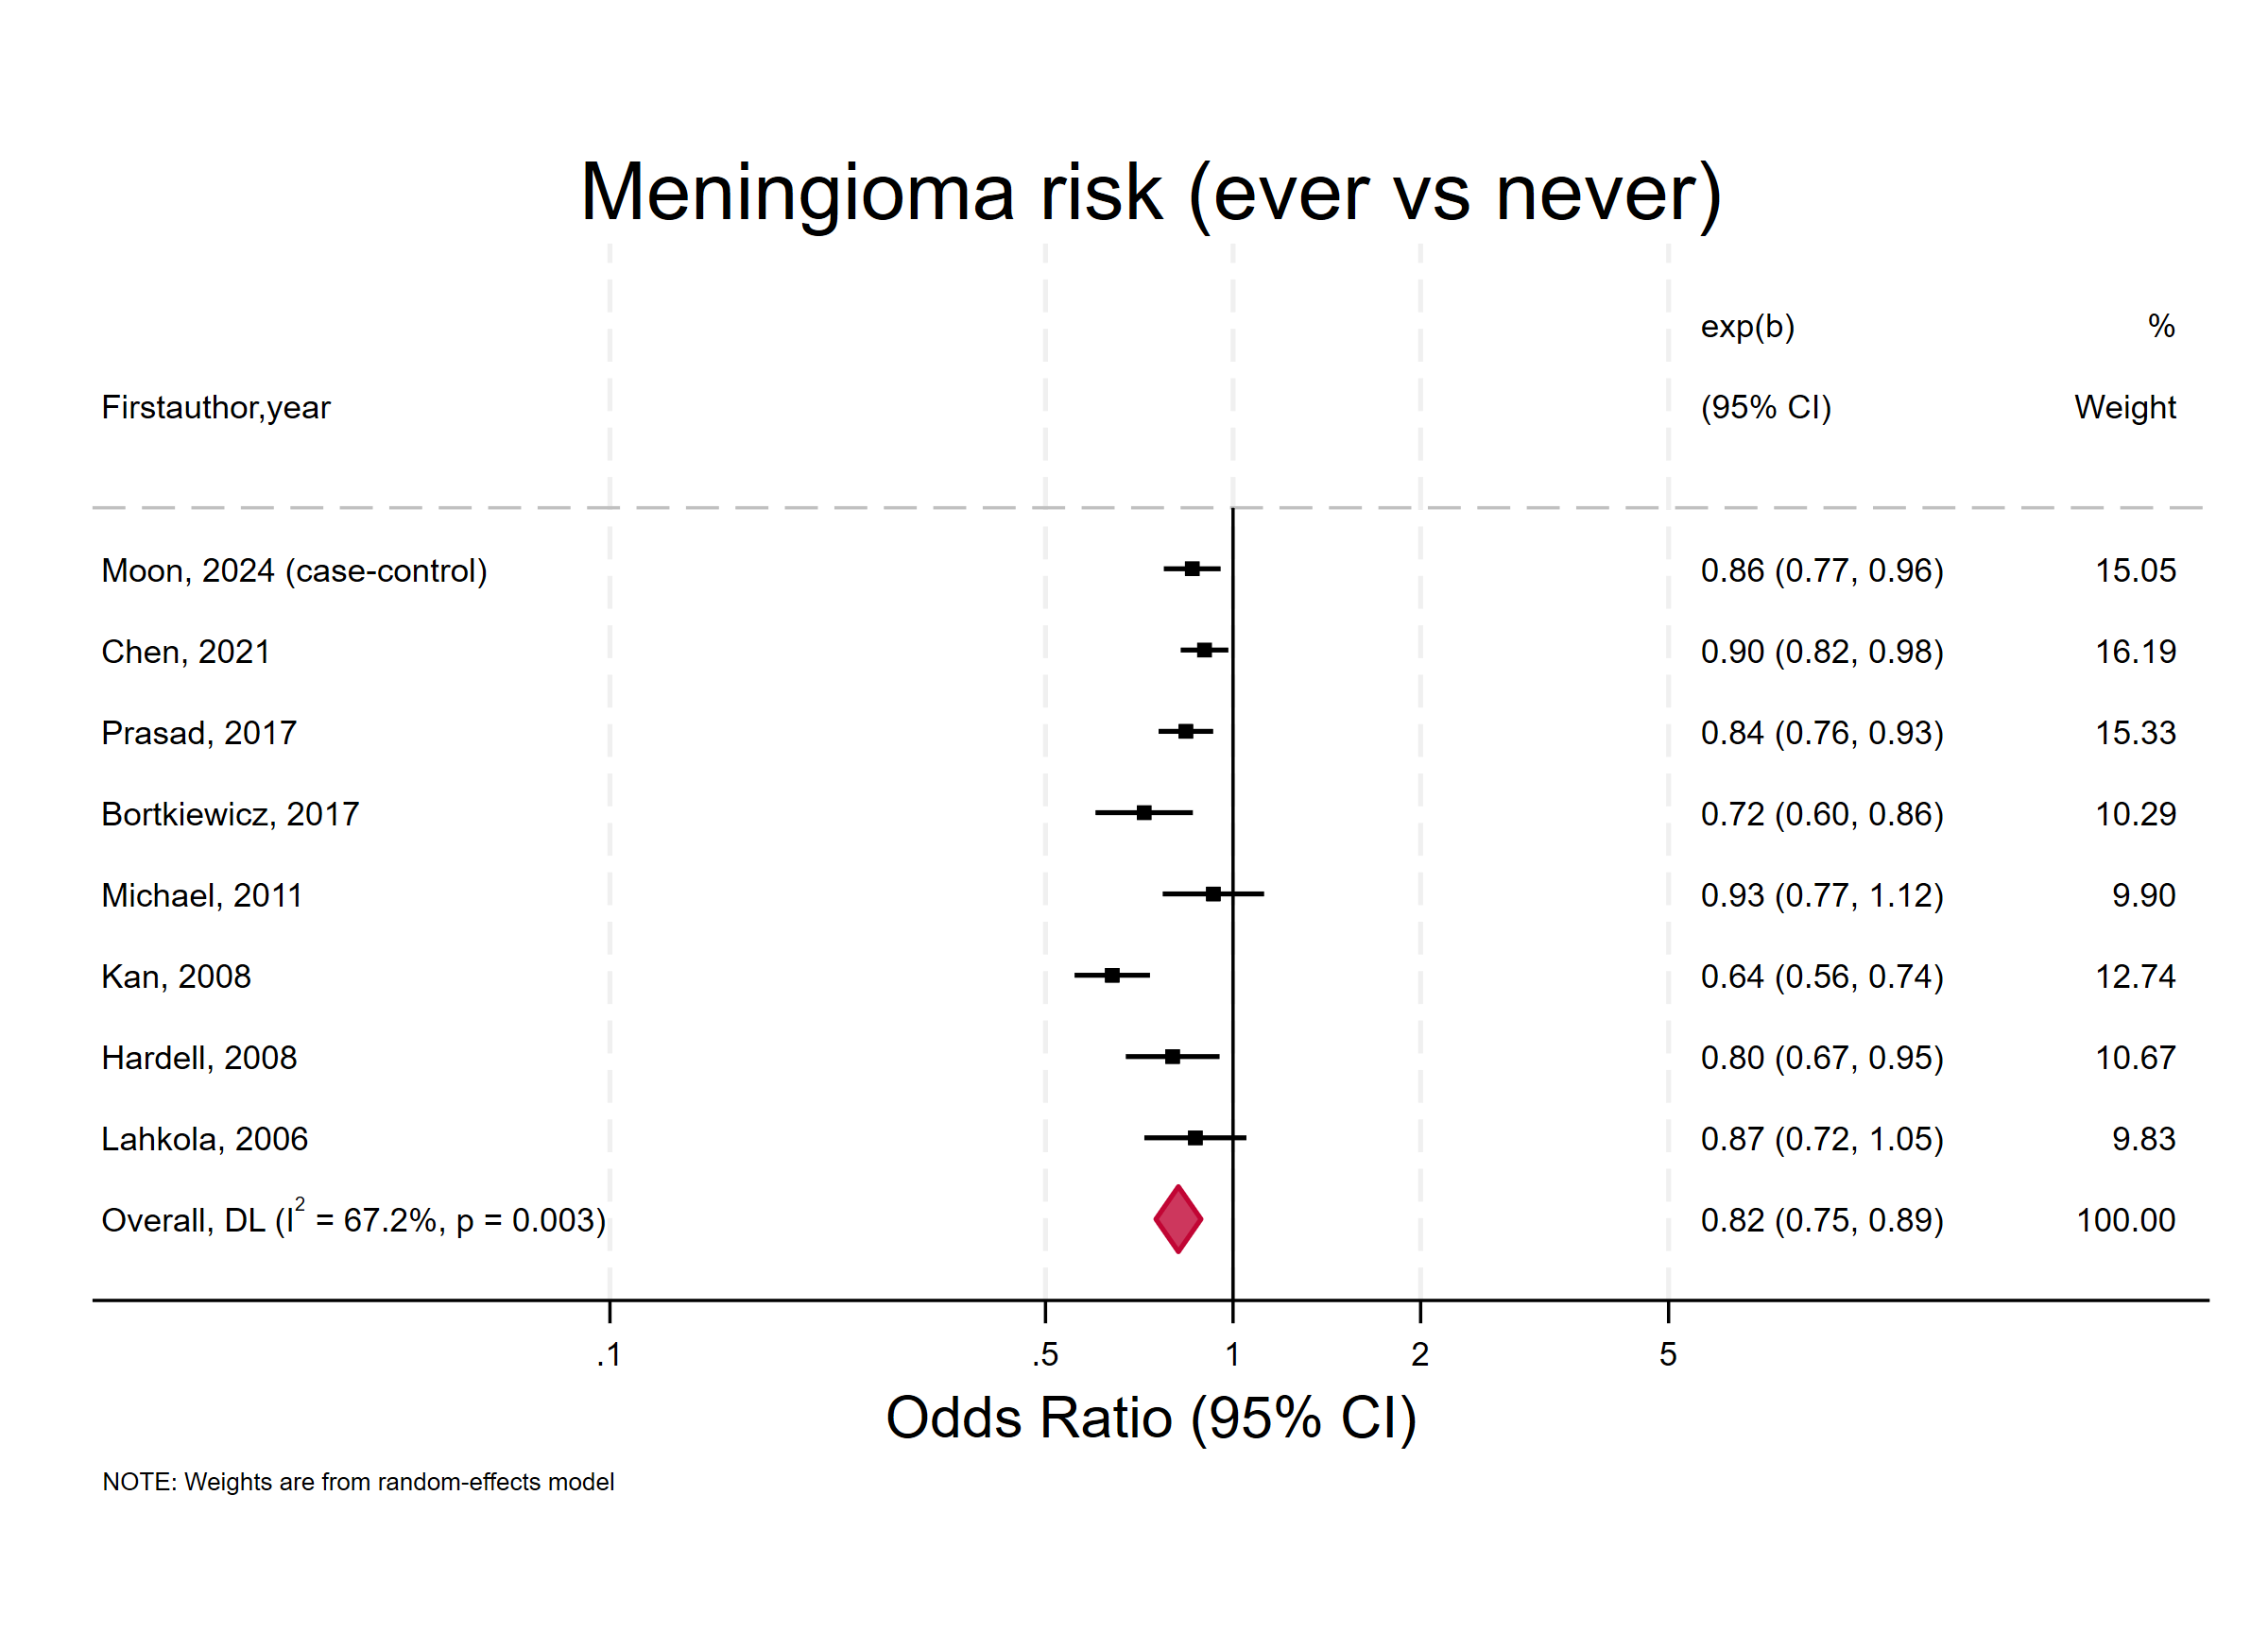

Supplementary Figure 3. Forest plot of the association between ever versus never mobile phone use and the risk of glioma, expressed as ORs
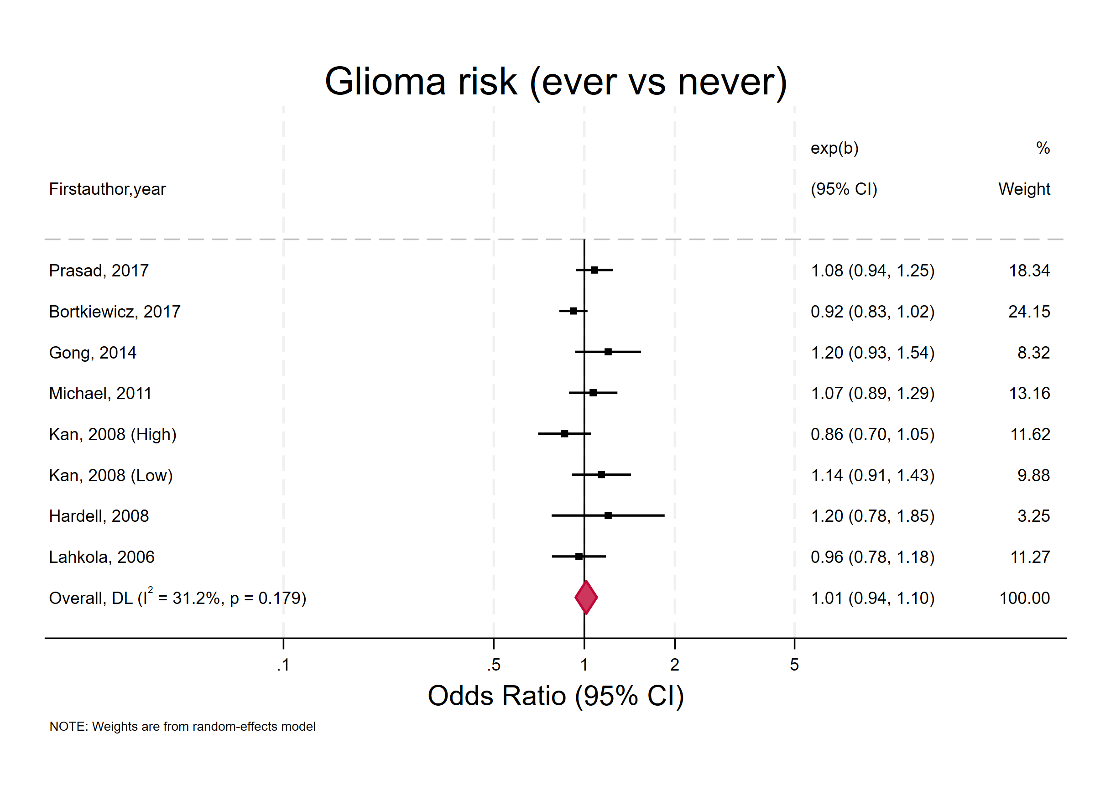
Supplementary Figure 4. Forest plot of the association between ever versus never mobile phone use and the risk of acoustic neuroma, expressed as ORs
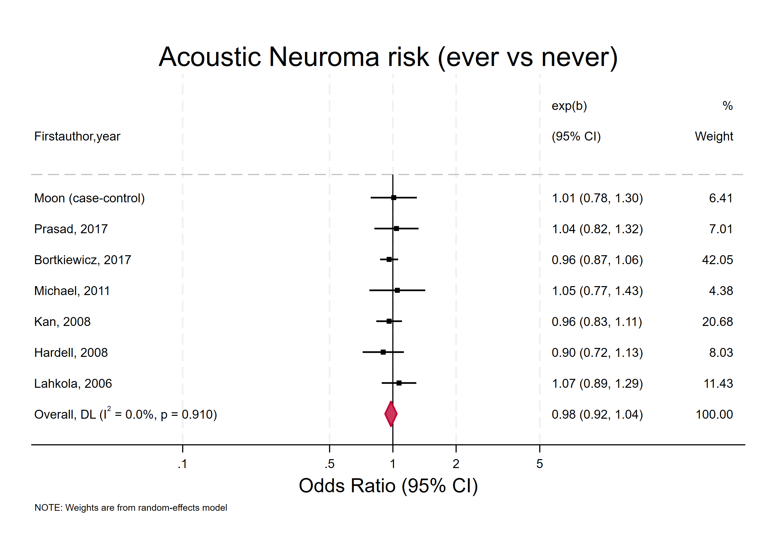
Supplementary Figure 5. Forest plot of the association between ever versus never mobile phone use and the risk of parotid gland tumor, expressed as ORs
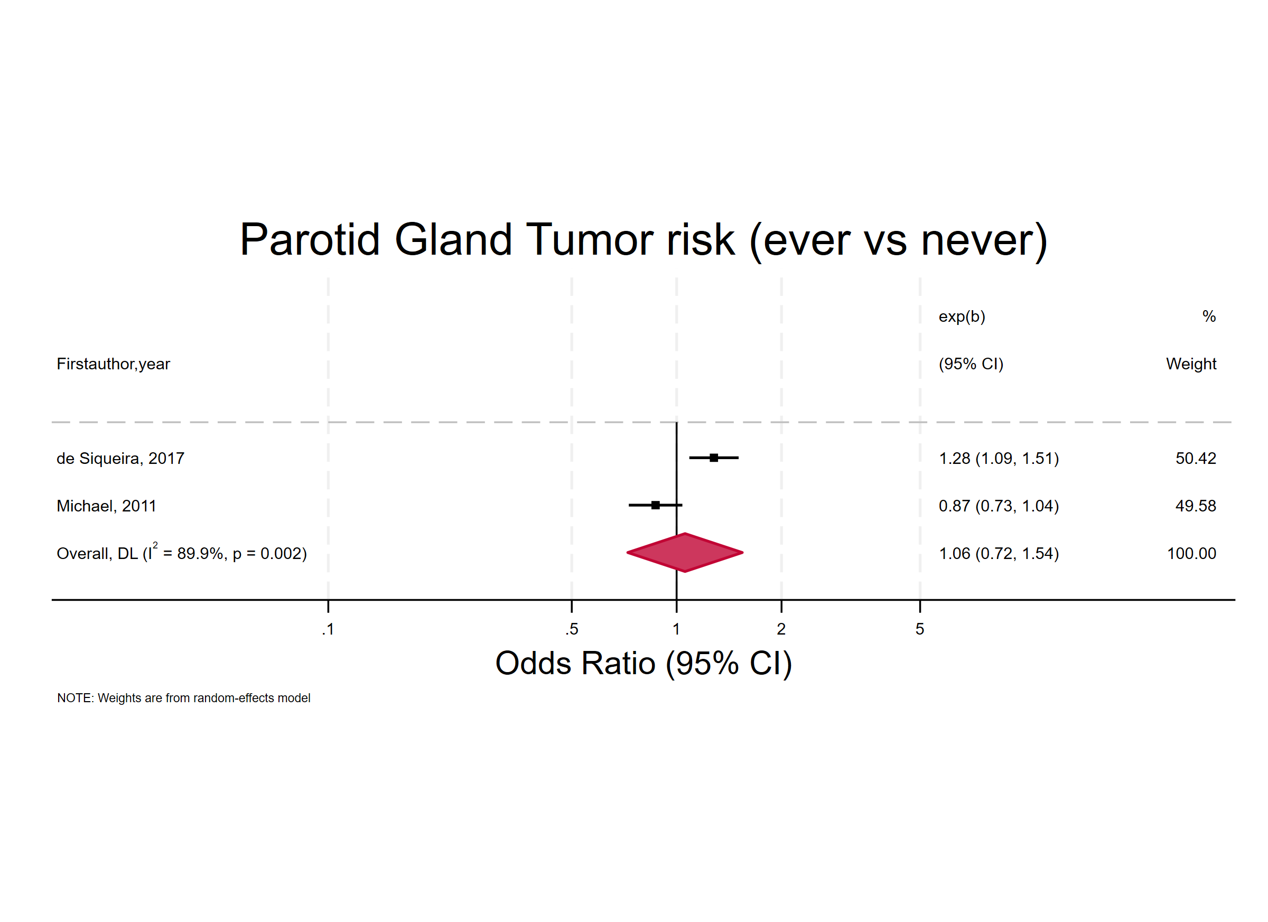

Supplementary Figure 6. Forest plot of the association between ever versus never mobile phone use and the risk of intracranial tumors, expressed as ORs
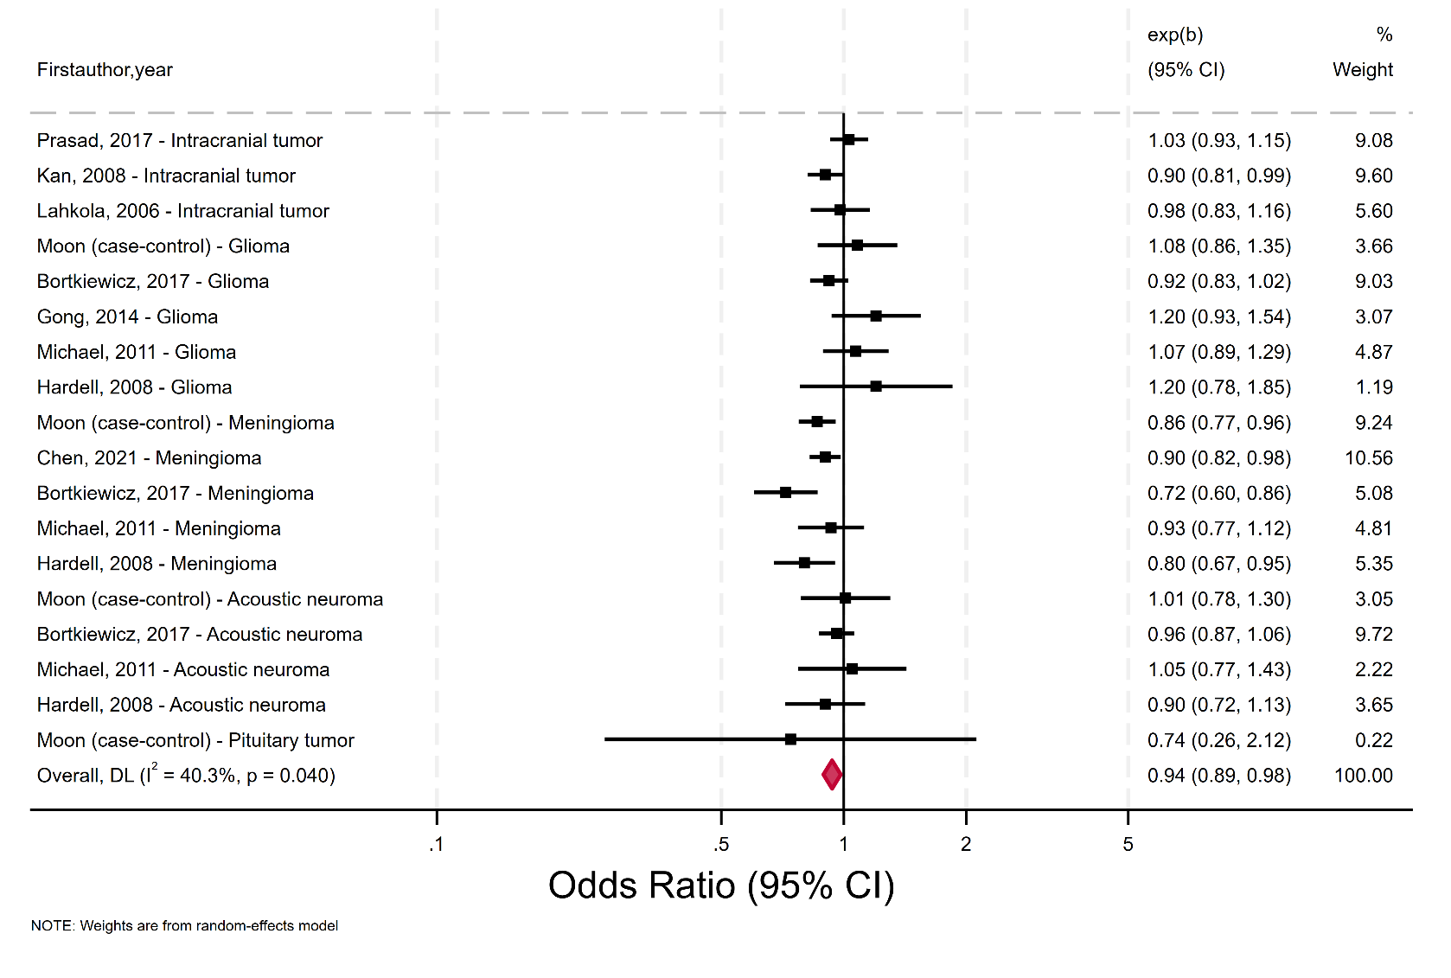
Supplementary Figure 7. Forest plot of the association between ever versus never mobile phone use and the risk of all brain tumor, expressed as ORs
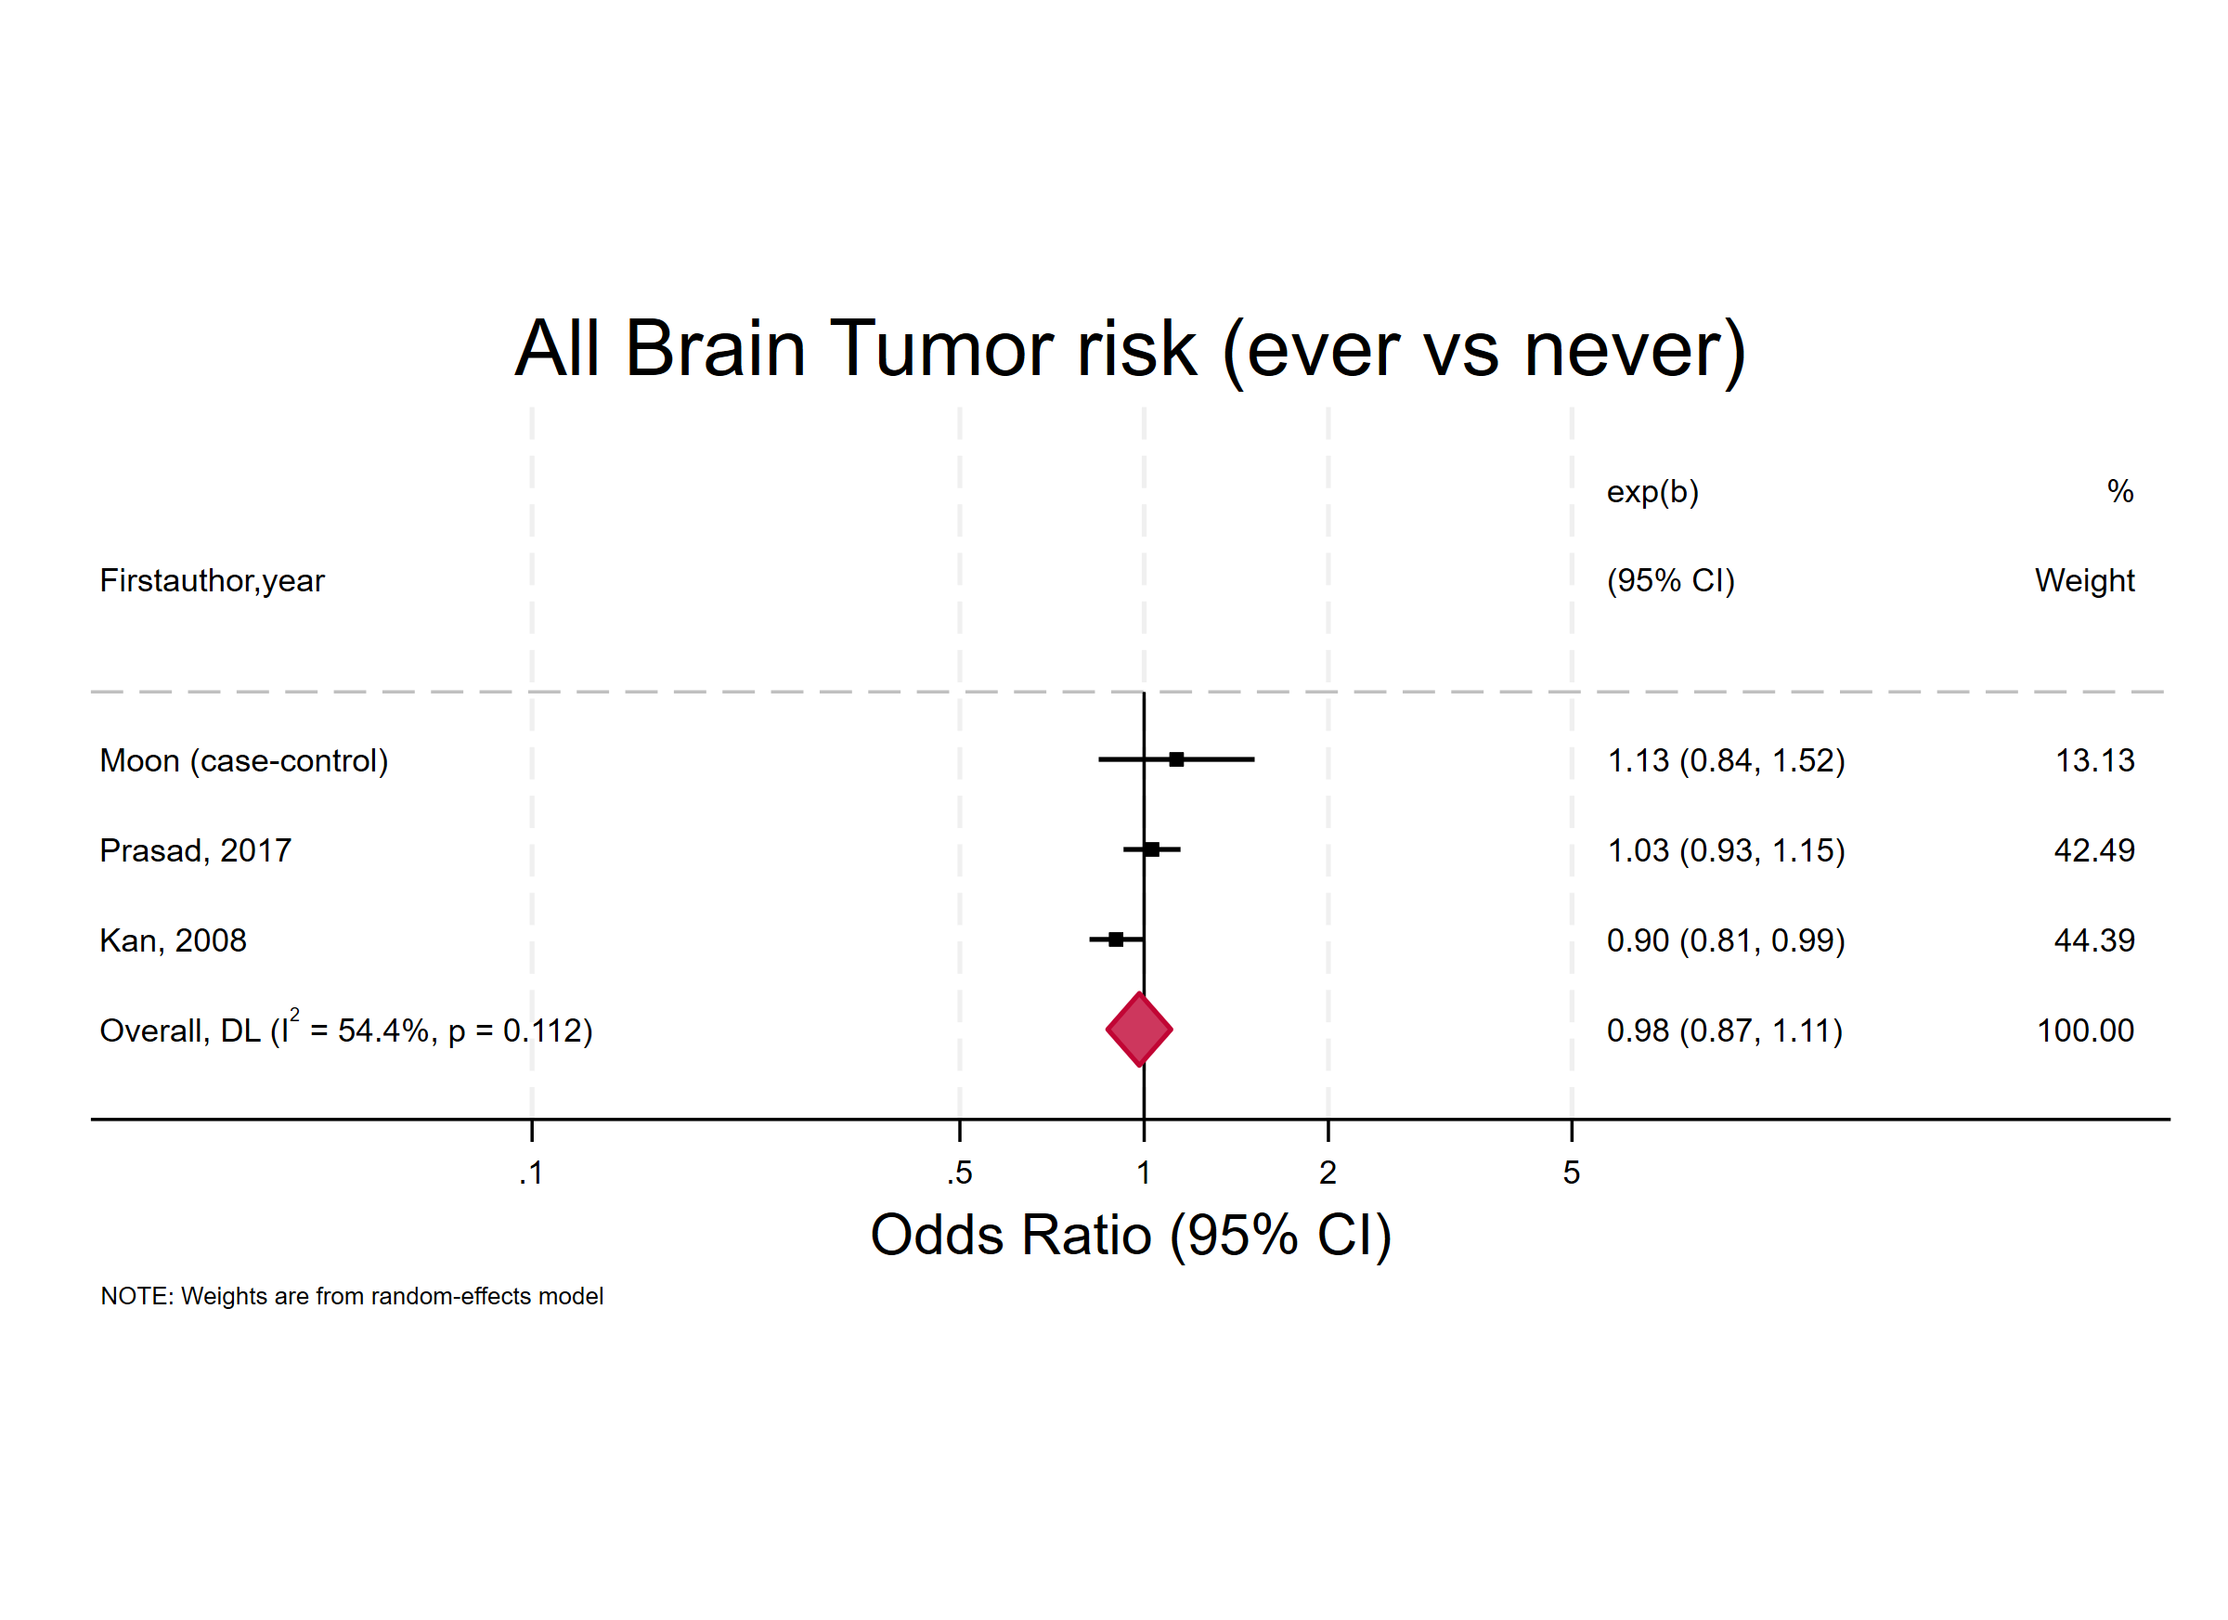

Supplementary Figure 8. Forest plot of the association between ever versus never mobile phone use and the risk of meningioma, expressed as relative risks (RRs)
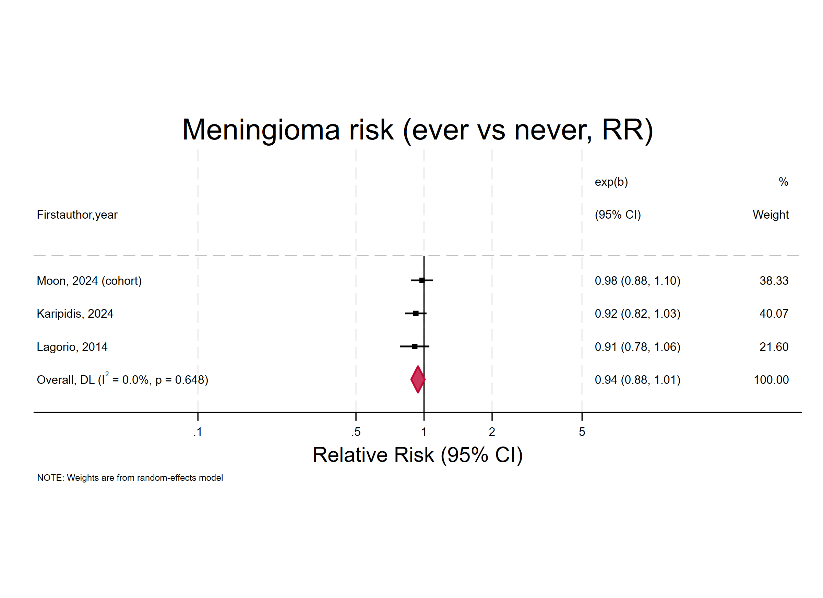

Supplementary Figure 9. Forest plot of the association between ever versus never mobile phone use and the risk of glioma, expressed as RRs
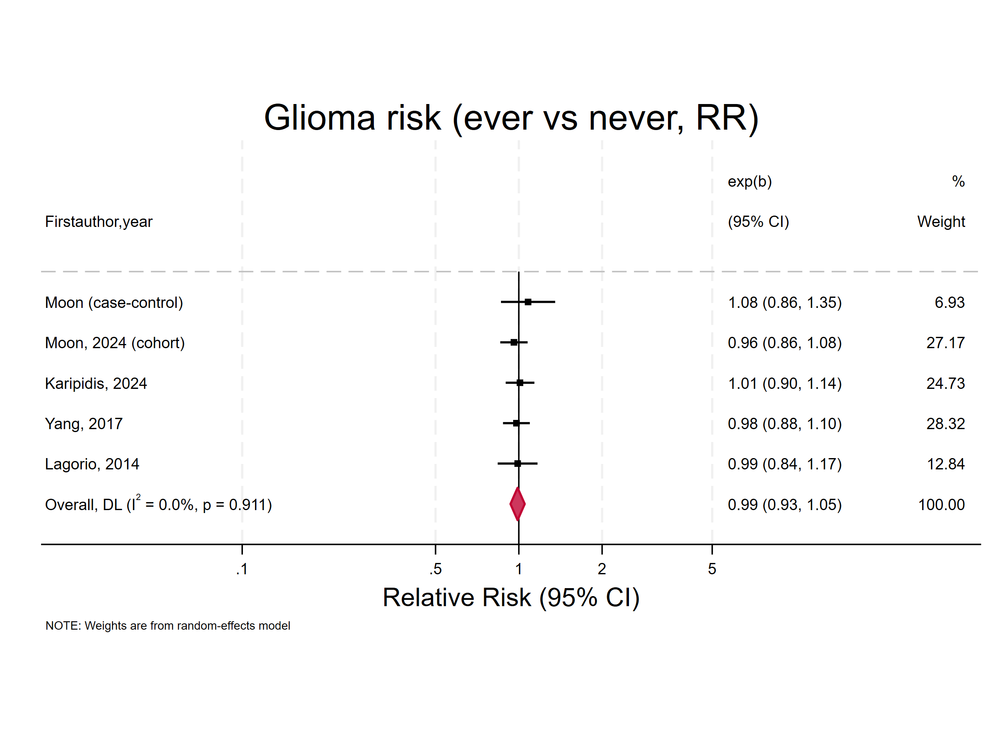

Supplementary Figure 10. Forest plot of the association between ever versus never mobile phone use and the risk of acoustic neuroma, expressed as RRs
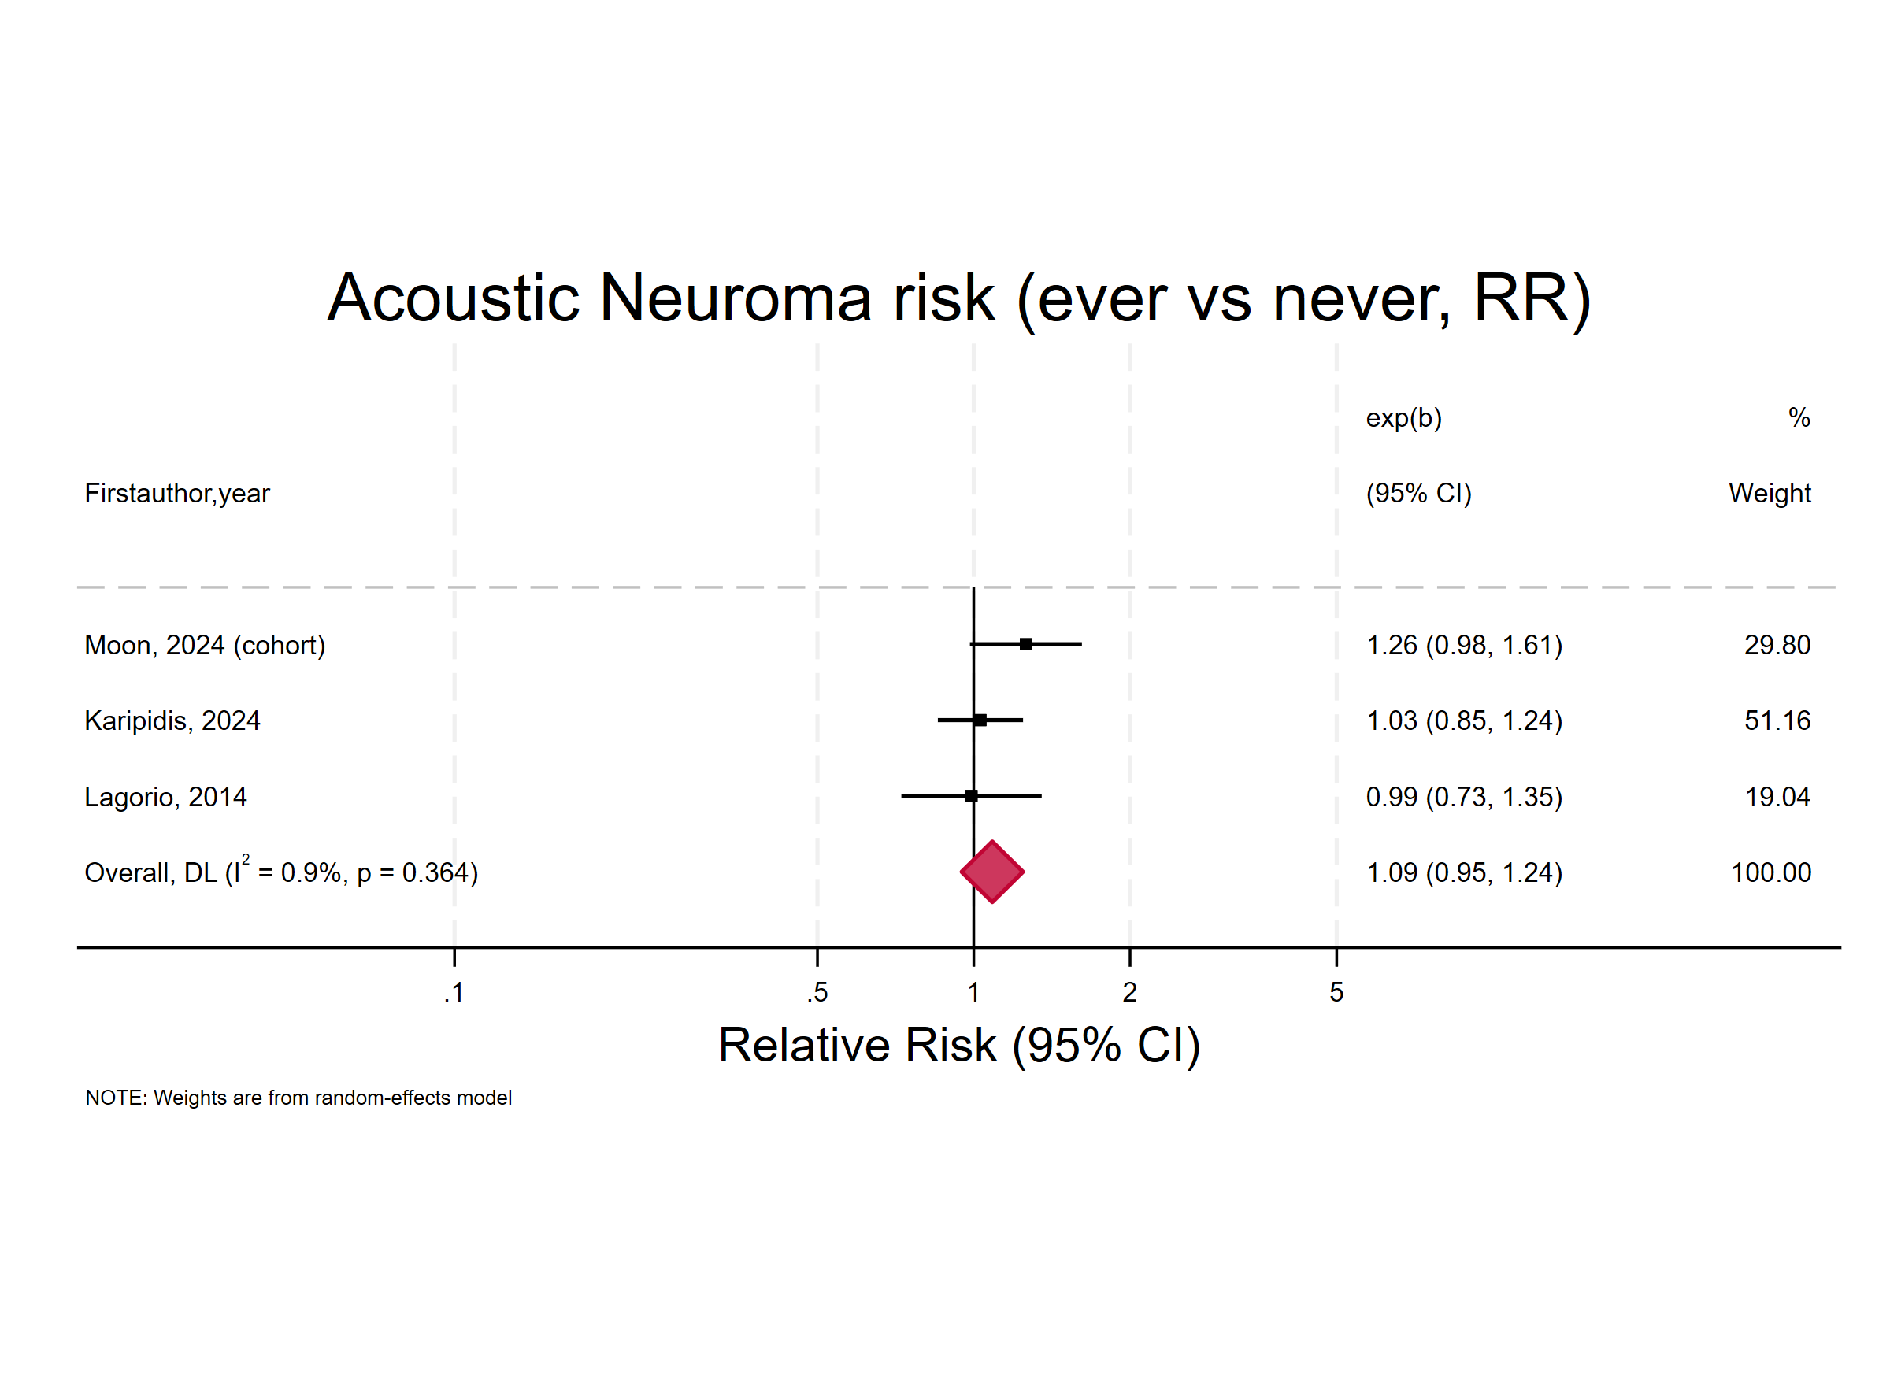

Supplementary Figure 11. Forest plot of the association between ever versus never mobile phone use and the risk of intracranial tumor, expressed as RRs
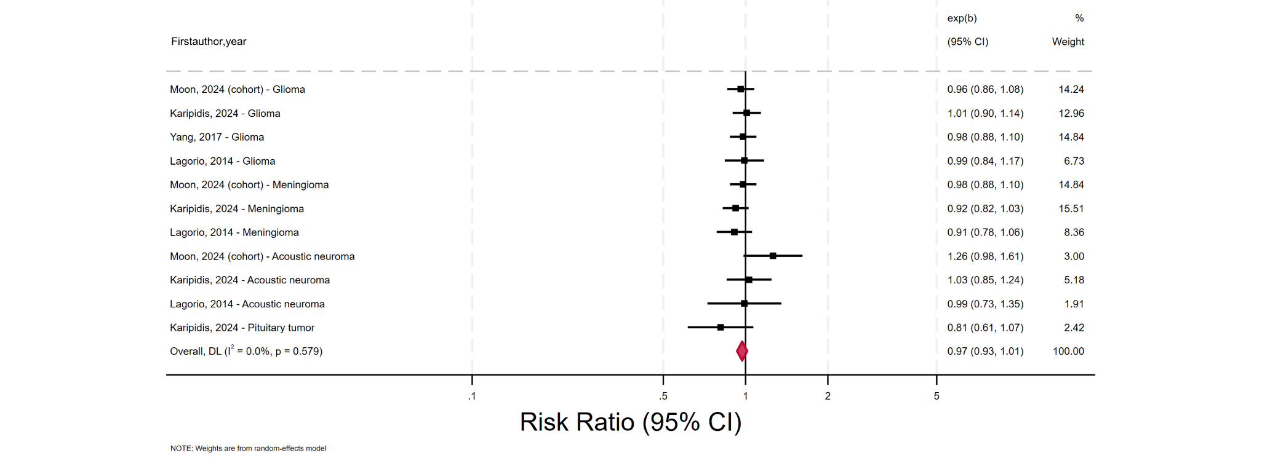

Supplementary Figure 12. Forest plot of the association between ever versus never mobile phone use and the risk of all brain tumor, expressed as RRs
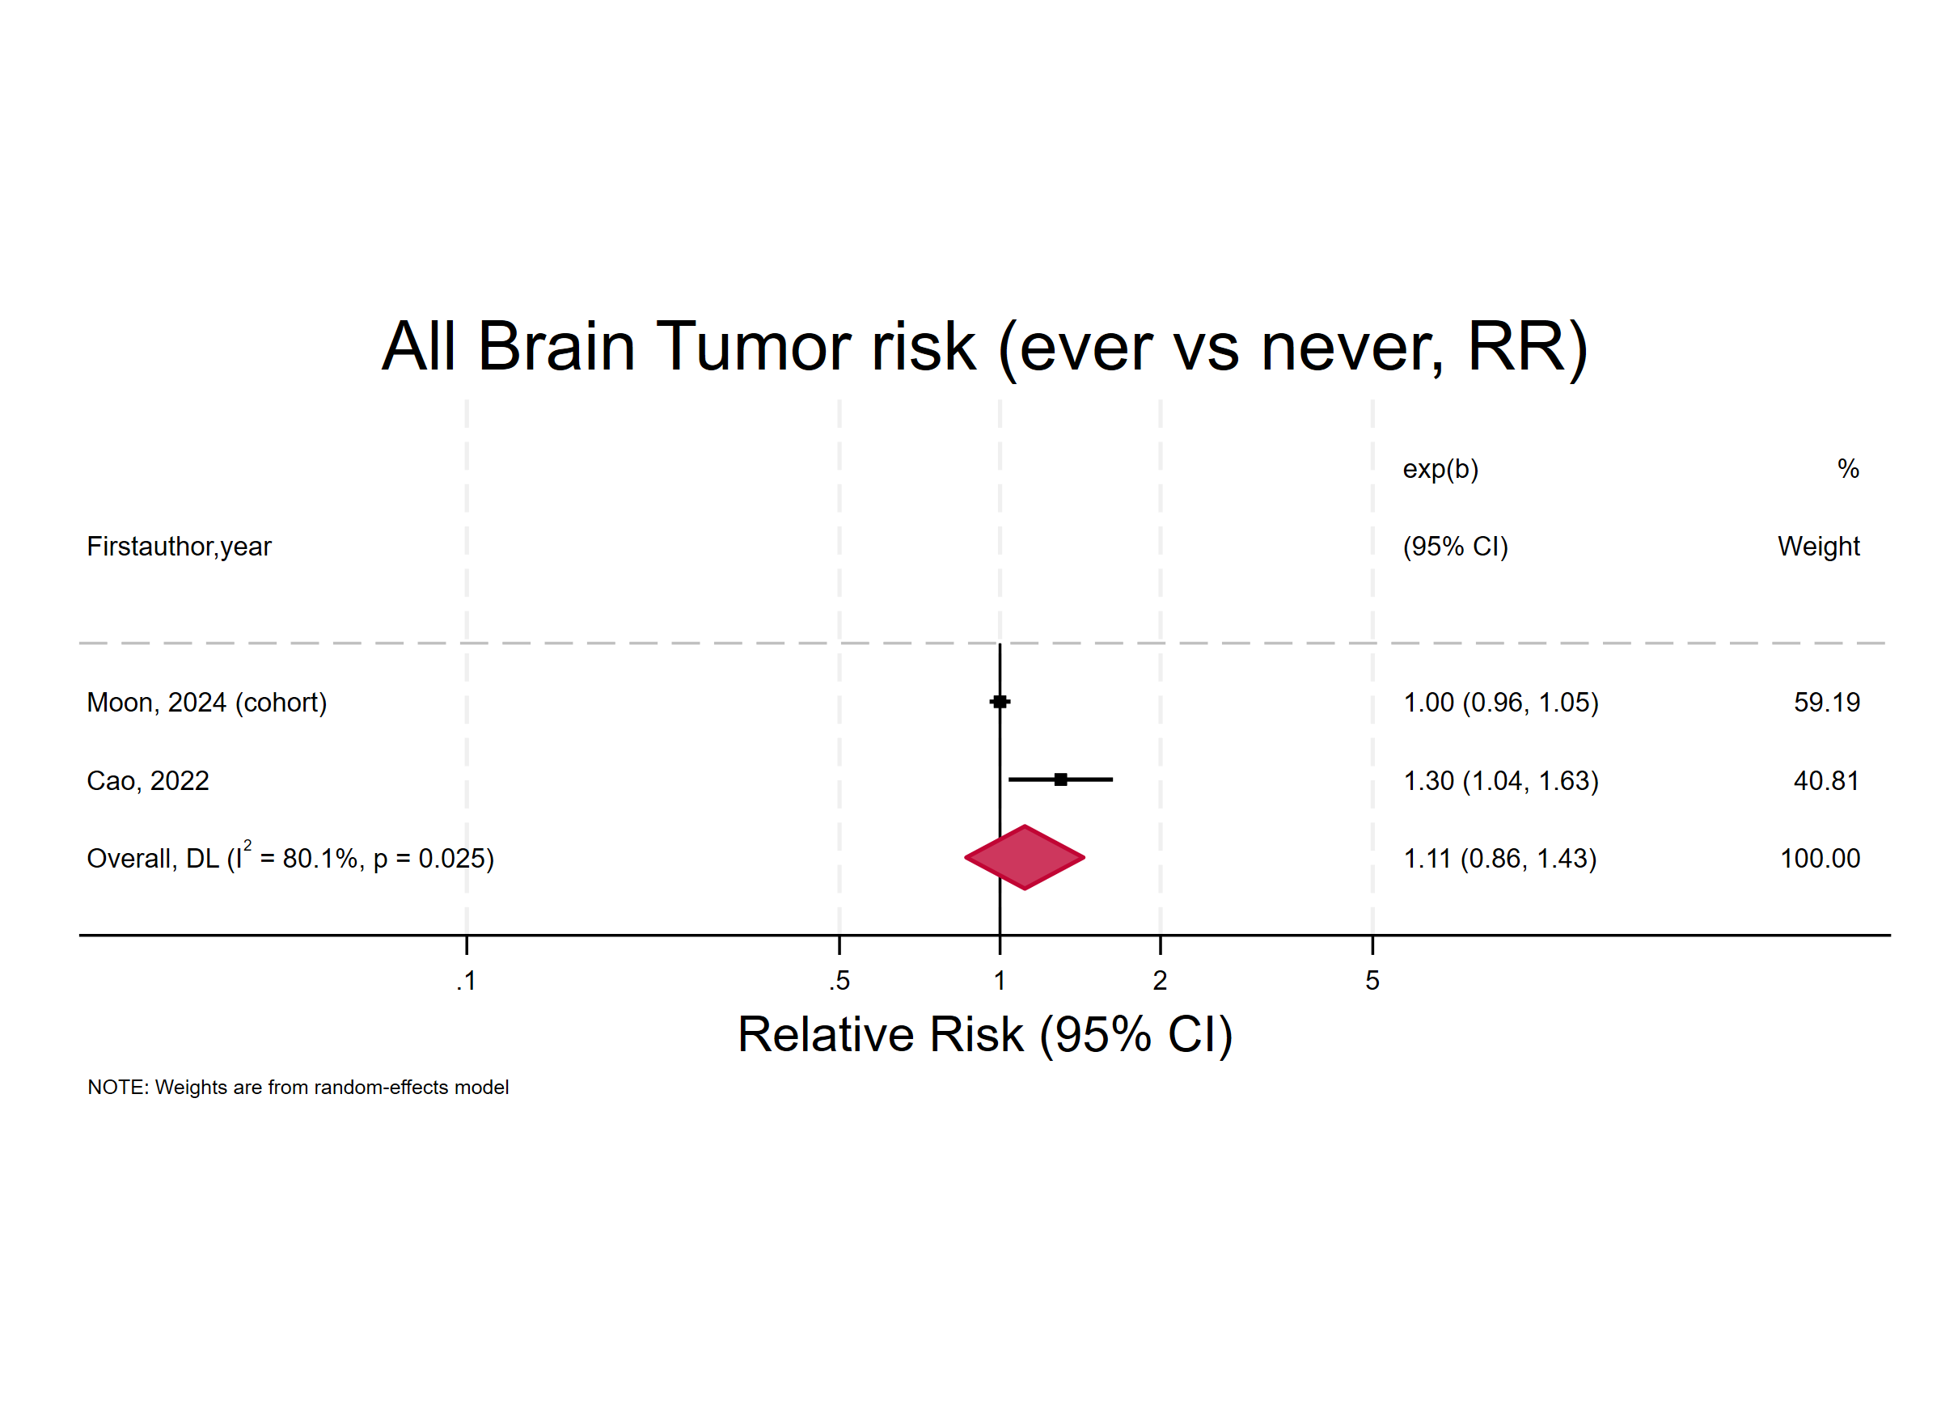

Supplementary Figure 13. Forest plot of the association between ever versus never mobile phone use and the risk of meningioma, expressed as ORs, restricted to studies rated as Moderate or High quality according to AMSTAR 2
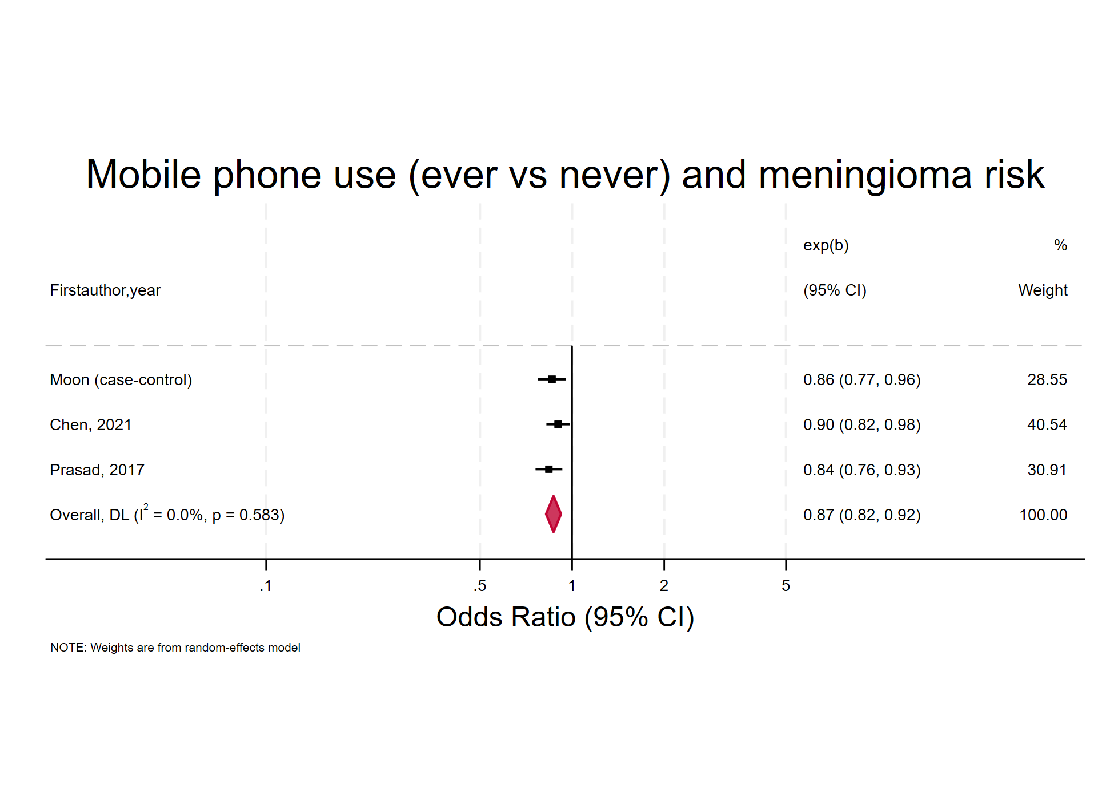

Supplementary Figure 14. Forest plot of the association between ever versus never mobile phone use and the risk of glioma, expressed as ORs, restricted to studies rated as Moderate or High quality according to AMSTAR 2
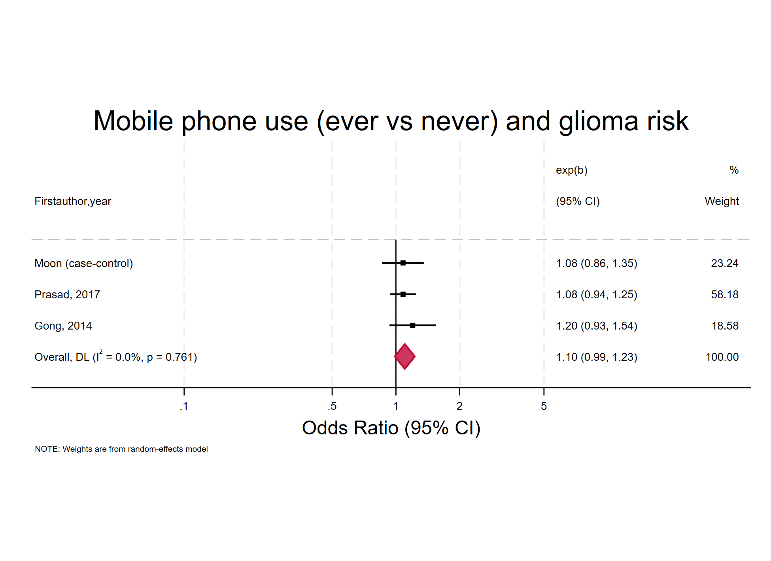

Supplementary Figure 15. Forest plot of the association between ever versus never mobile phone use and the risk of acoustic neuroma, expressed as ORs, restricted to studies rated as Moderate or High quality according to AMSTAR 2
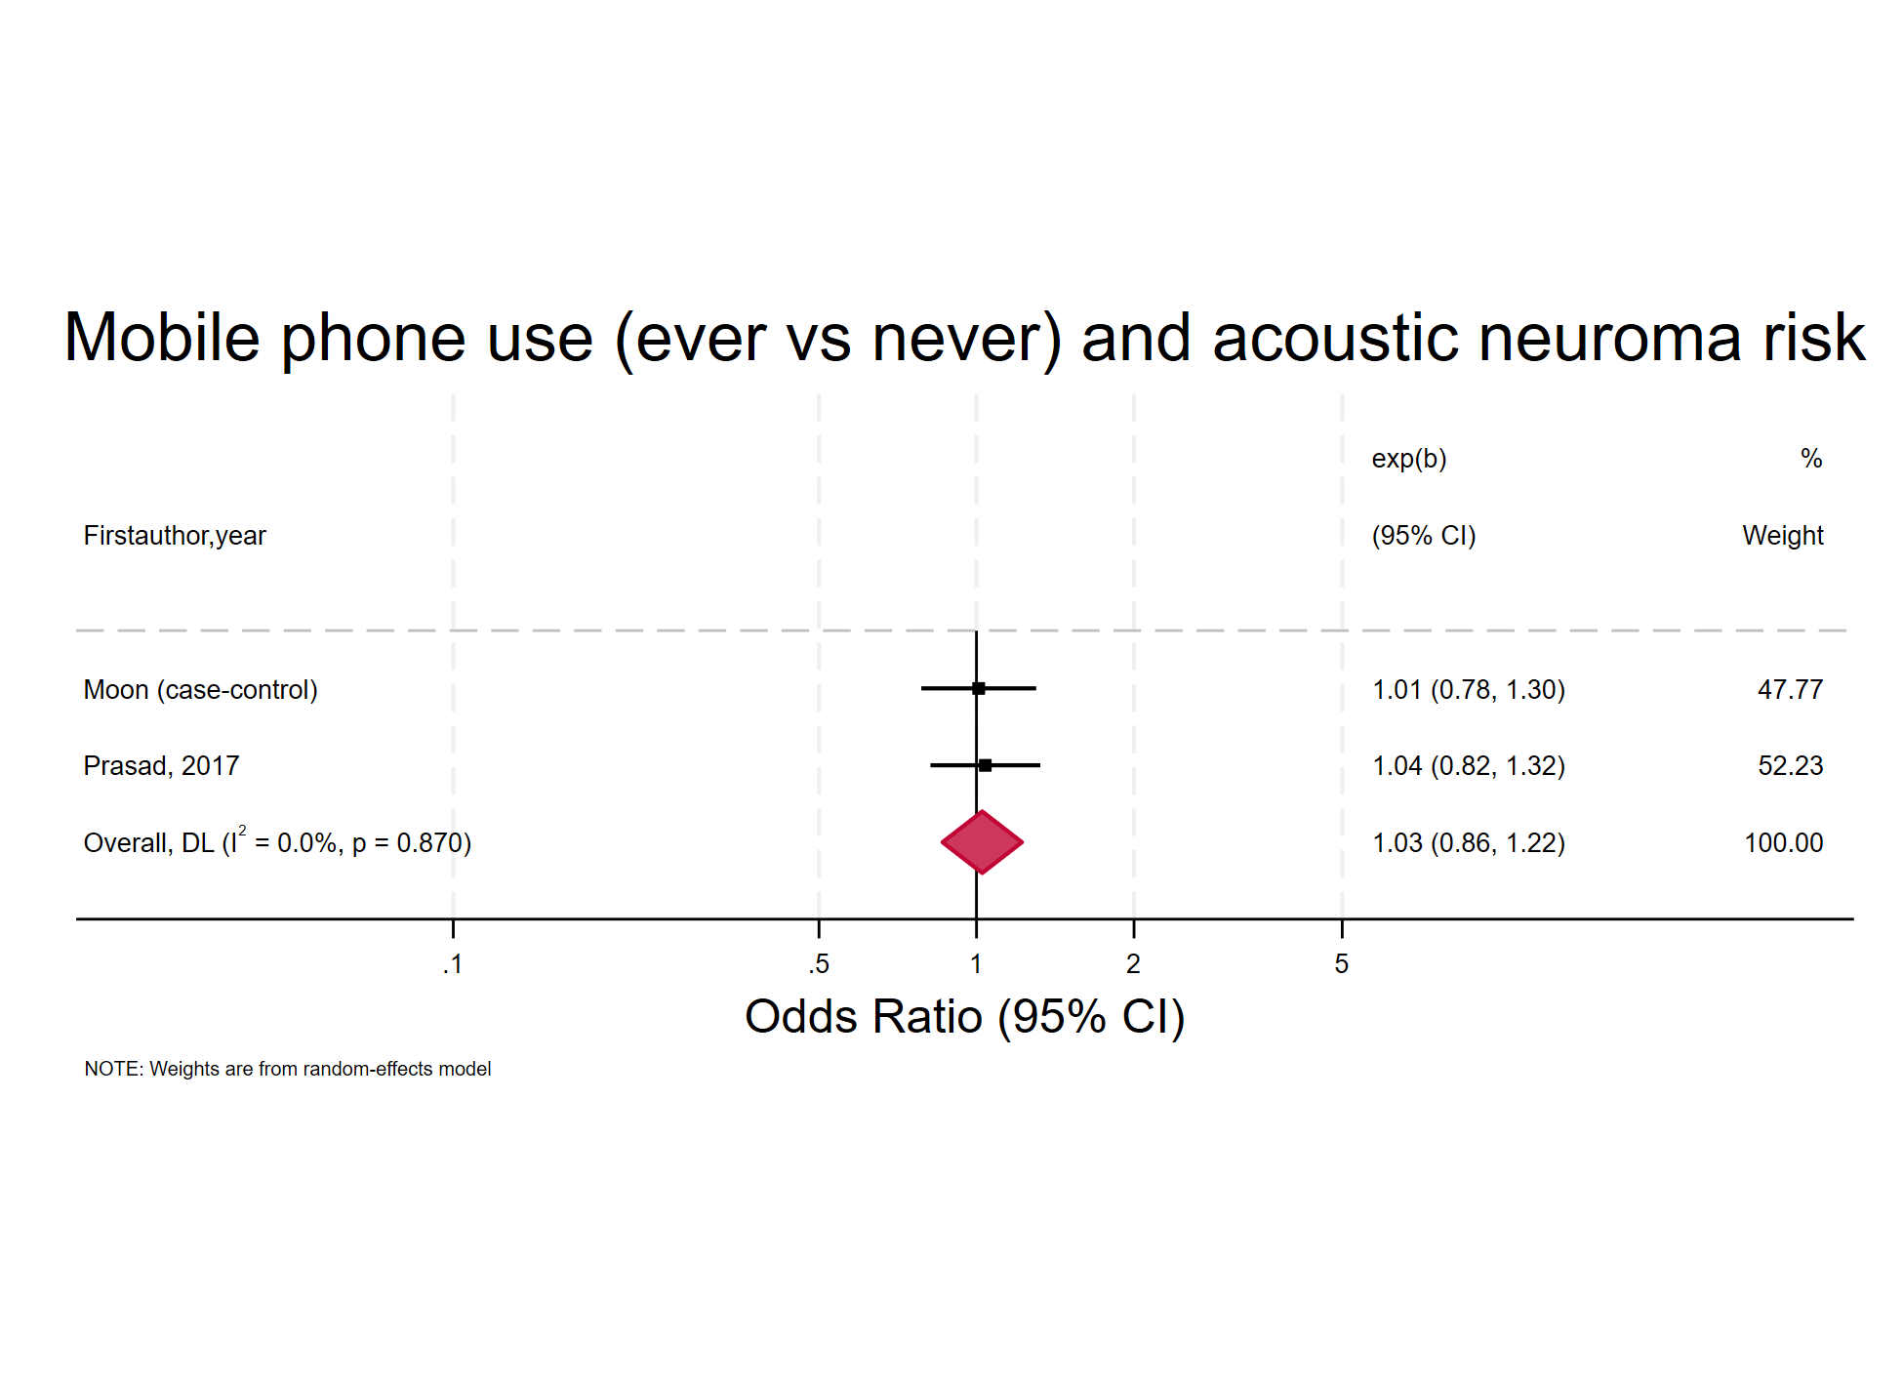

Supplementary Figure 16. Forest plot of the association between ever versus never mobile phone use and the risk of intracranial tumor, expressed as ORs, restricted to studies rated as Moderate or High quality according to AMSTAR 2
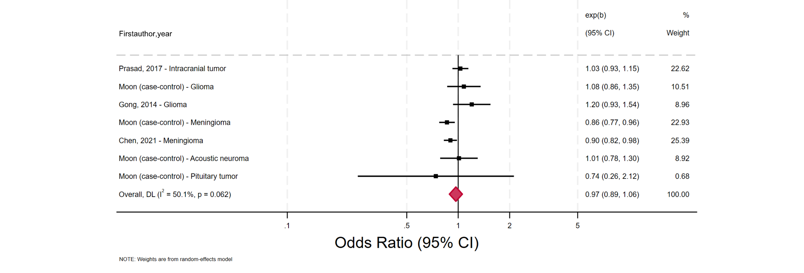

Supplementary Figure 17. Forest plot of the association between ever versus never mobile phone use and the risk of intracranial tumor, expressed as RRs, restricted to studies rated as Moderate or High quality according to AMSTAR 2
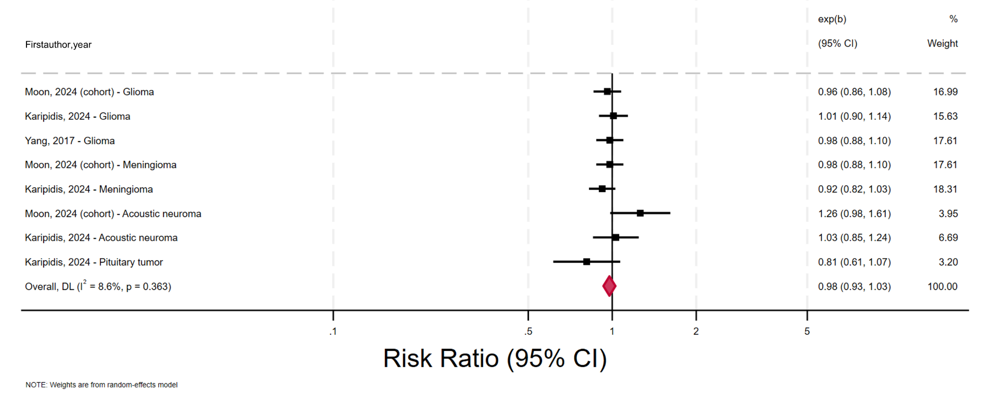

Supplementary Figure 18. Forest plot of the association between duration of mobile phone use and the risk of meningioma, expressed as ORs
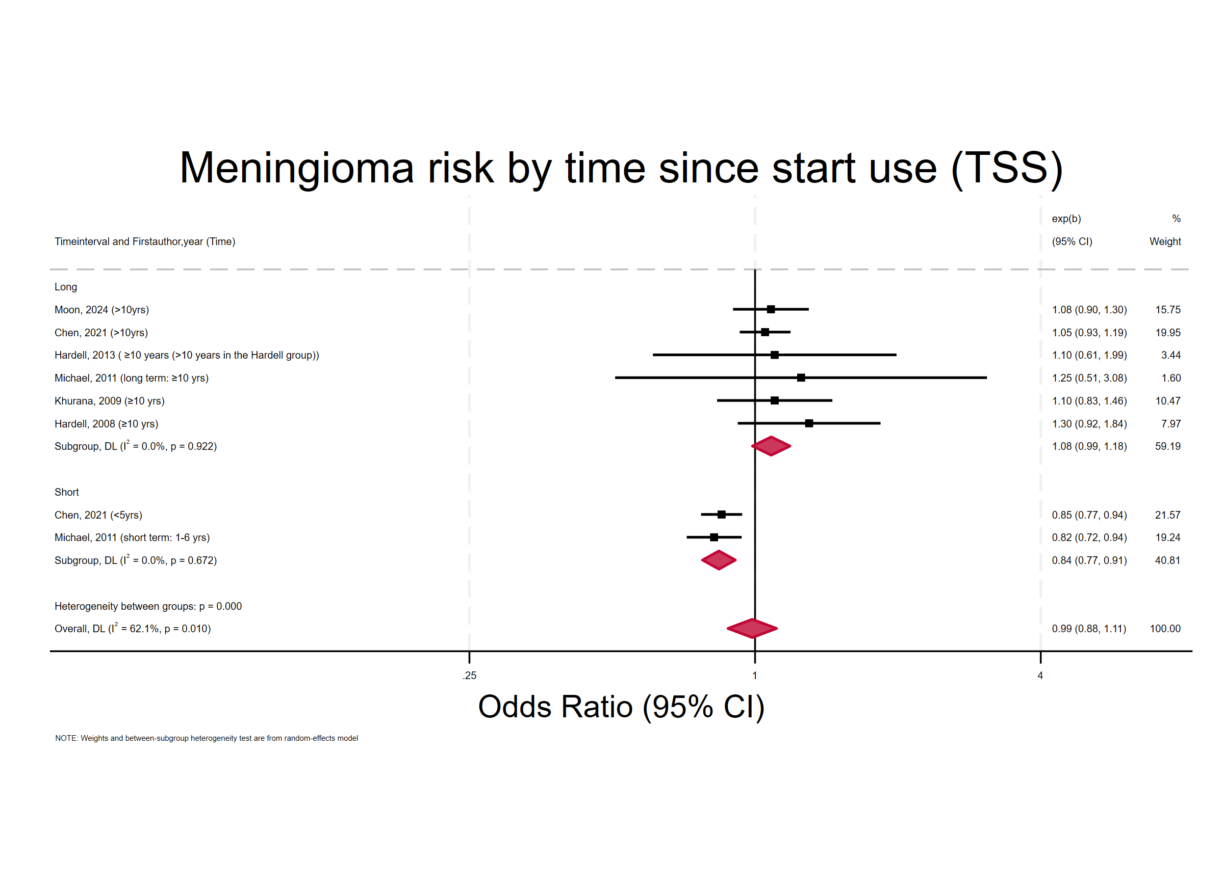

Supplementary Figure 19. Forest plot of the association between duration of mobile phone use and the risk of intracranial tumor, expressed as ORs
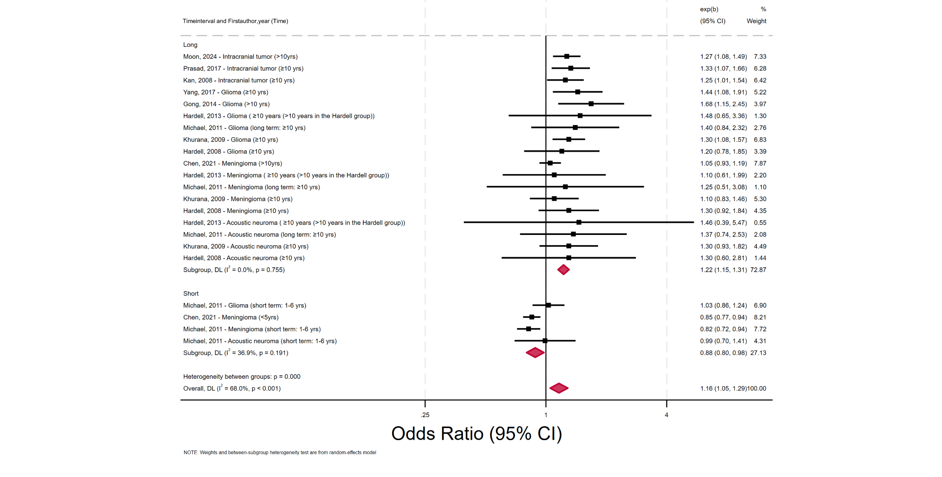
Supplementary Figure 20. Forest plot of the association between duration of mobile phone use and the risk of meningioma, expressed as RRs
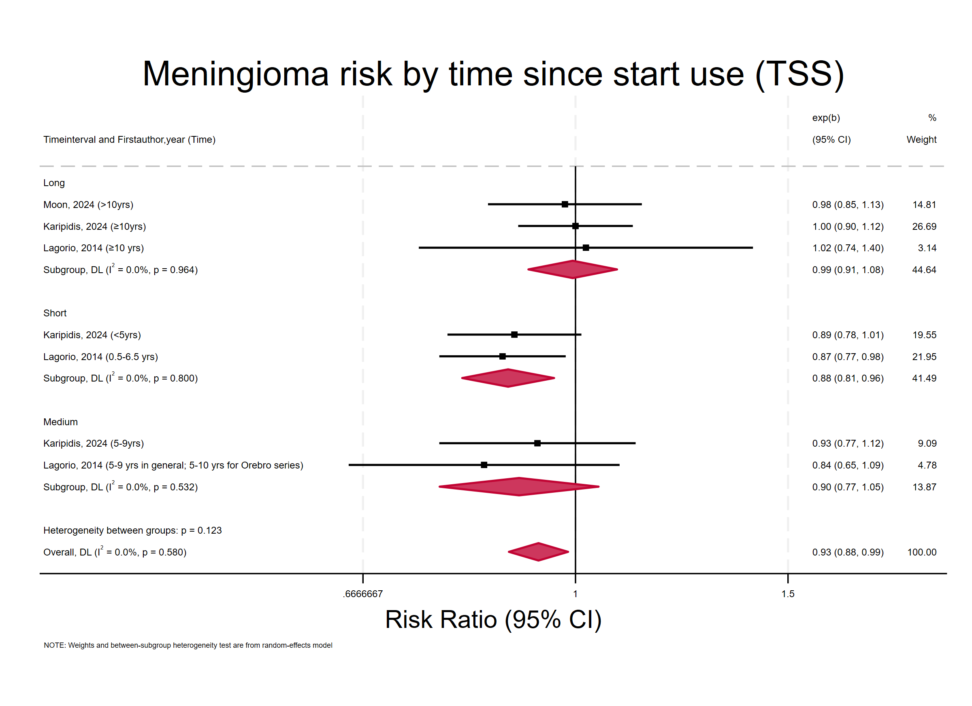
Supplementary Figure 21. Forest plot of the association between duration of mobile phone use and the risk of glioma, expressed as RRs
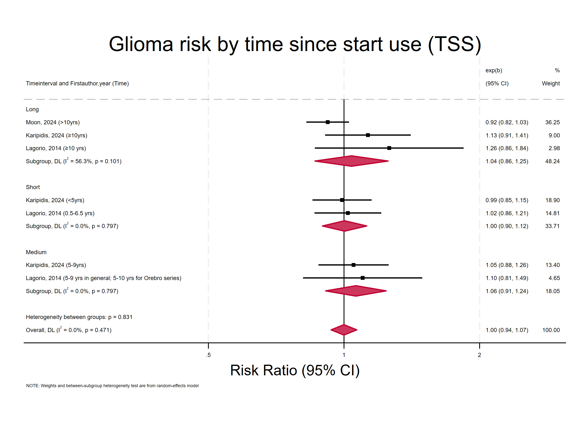

Supplementary Figure 22. Forest plot of the association between duration of mobile phone use and the risk of acoustic neuroma, expressed as RRs
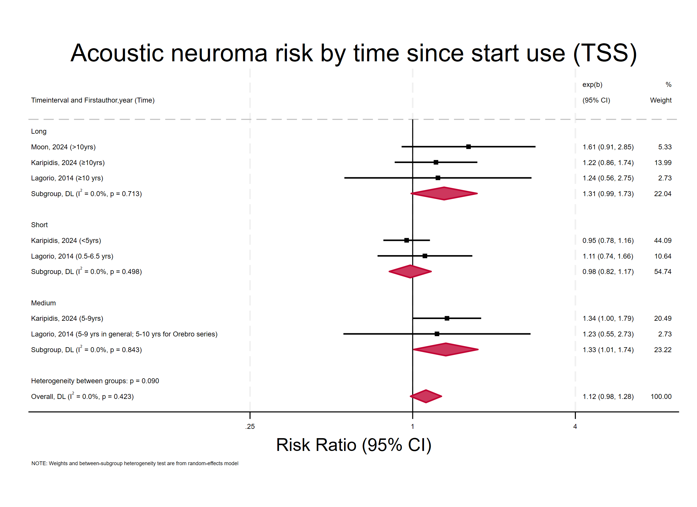
Supplementary Figure 23. Forest plot of the association between duration of mobile phone use and the risk of intracranial tumor, expressed as RRs
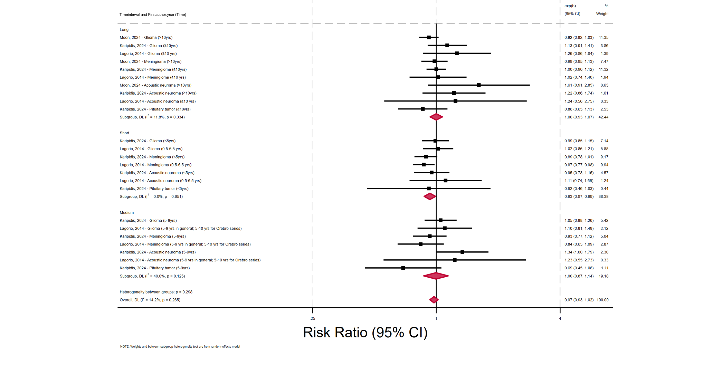
Supplementary Figure 24. Forest plot of the association between duration of mobile phone use and the risk of intracranial tumor, expressed as RRs, restricted to studies rated as Moderate or High quality according to AMSTAR 2
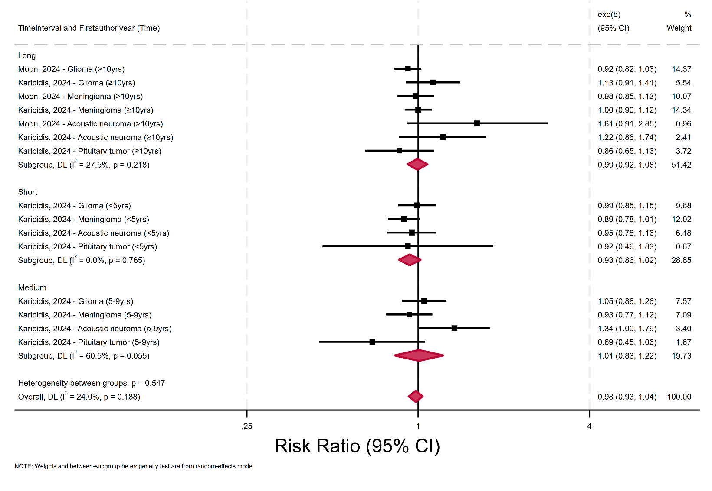
Supplementary Figure 25. Forest plot of the association between duration of mobile phone use and the risk of meningioma, expressed as RRs estimated using the delta method
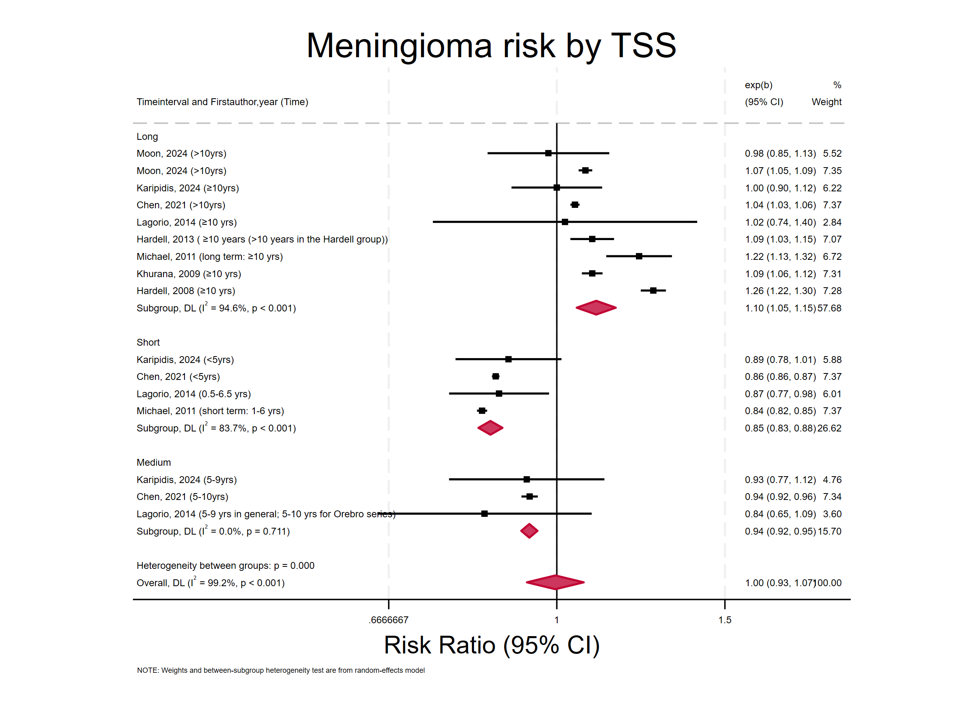
Supplementary Figure 26. Forest plot of the association between duration of mobile phone use and the risk of glioma, expressed as RRs estimated using the delta method
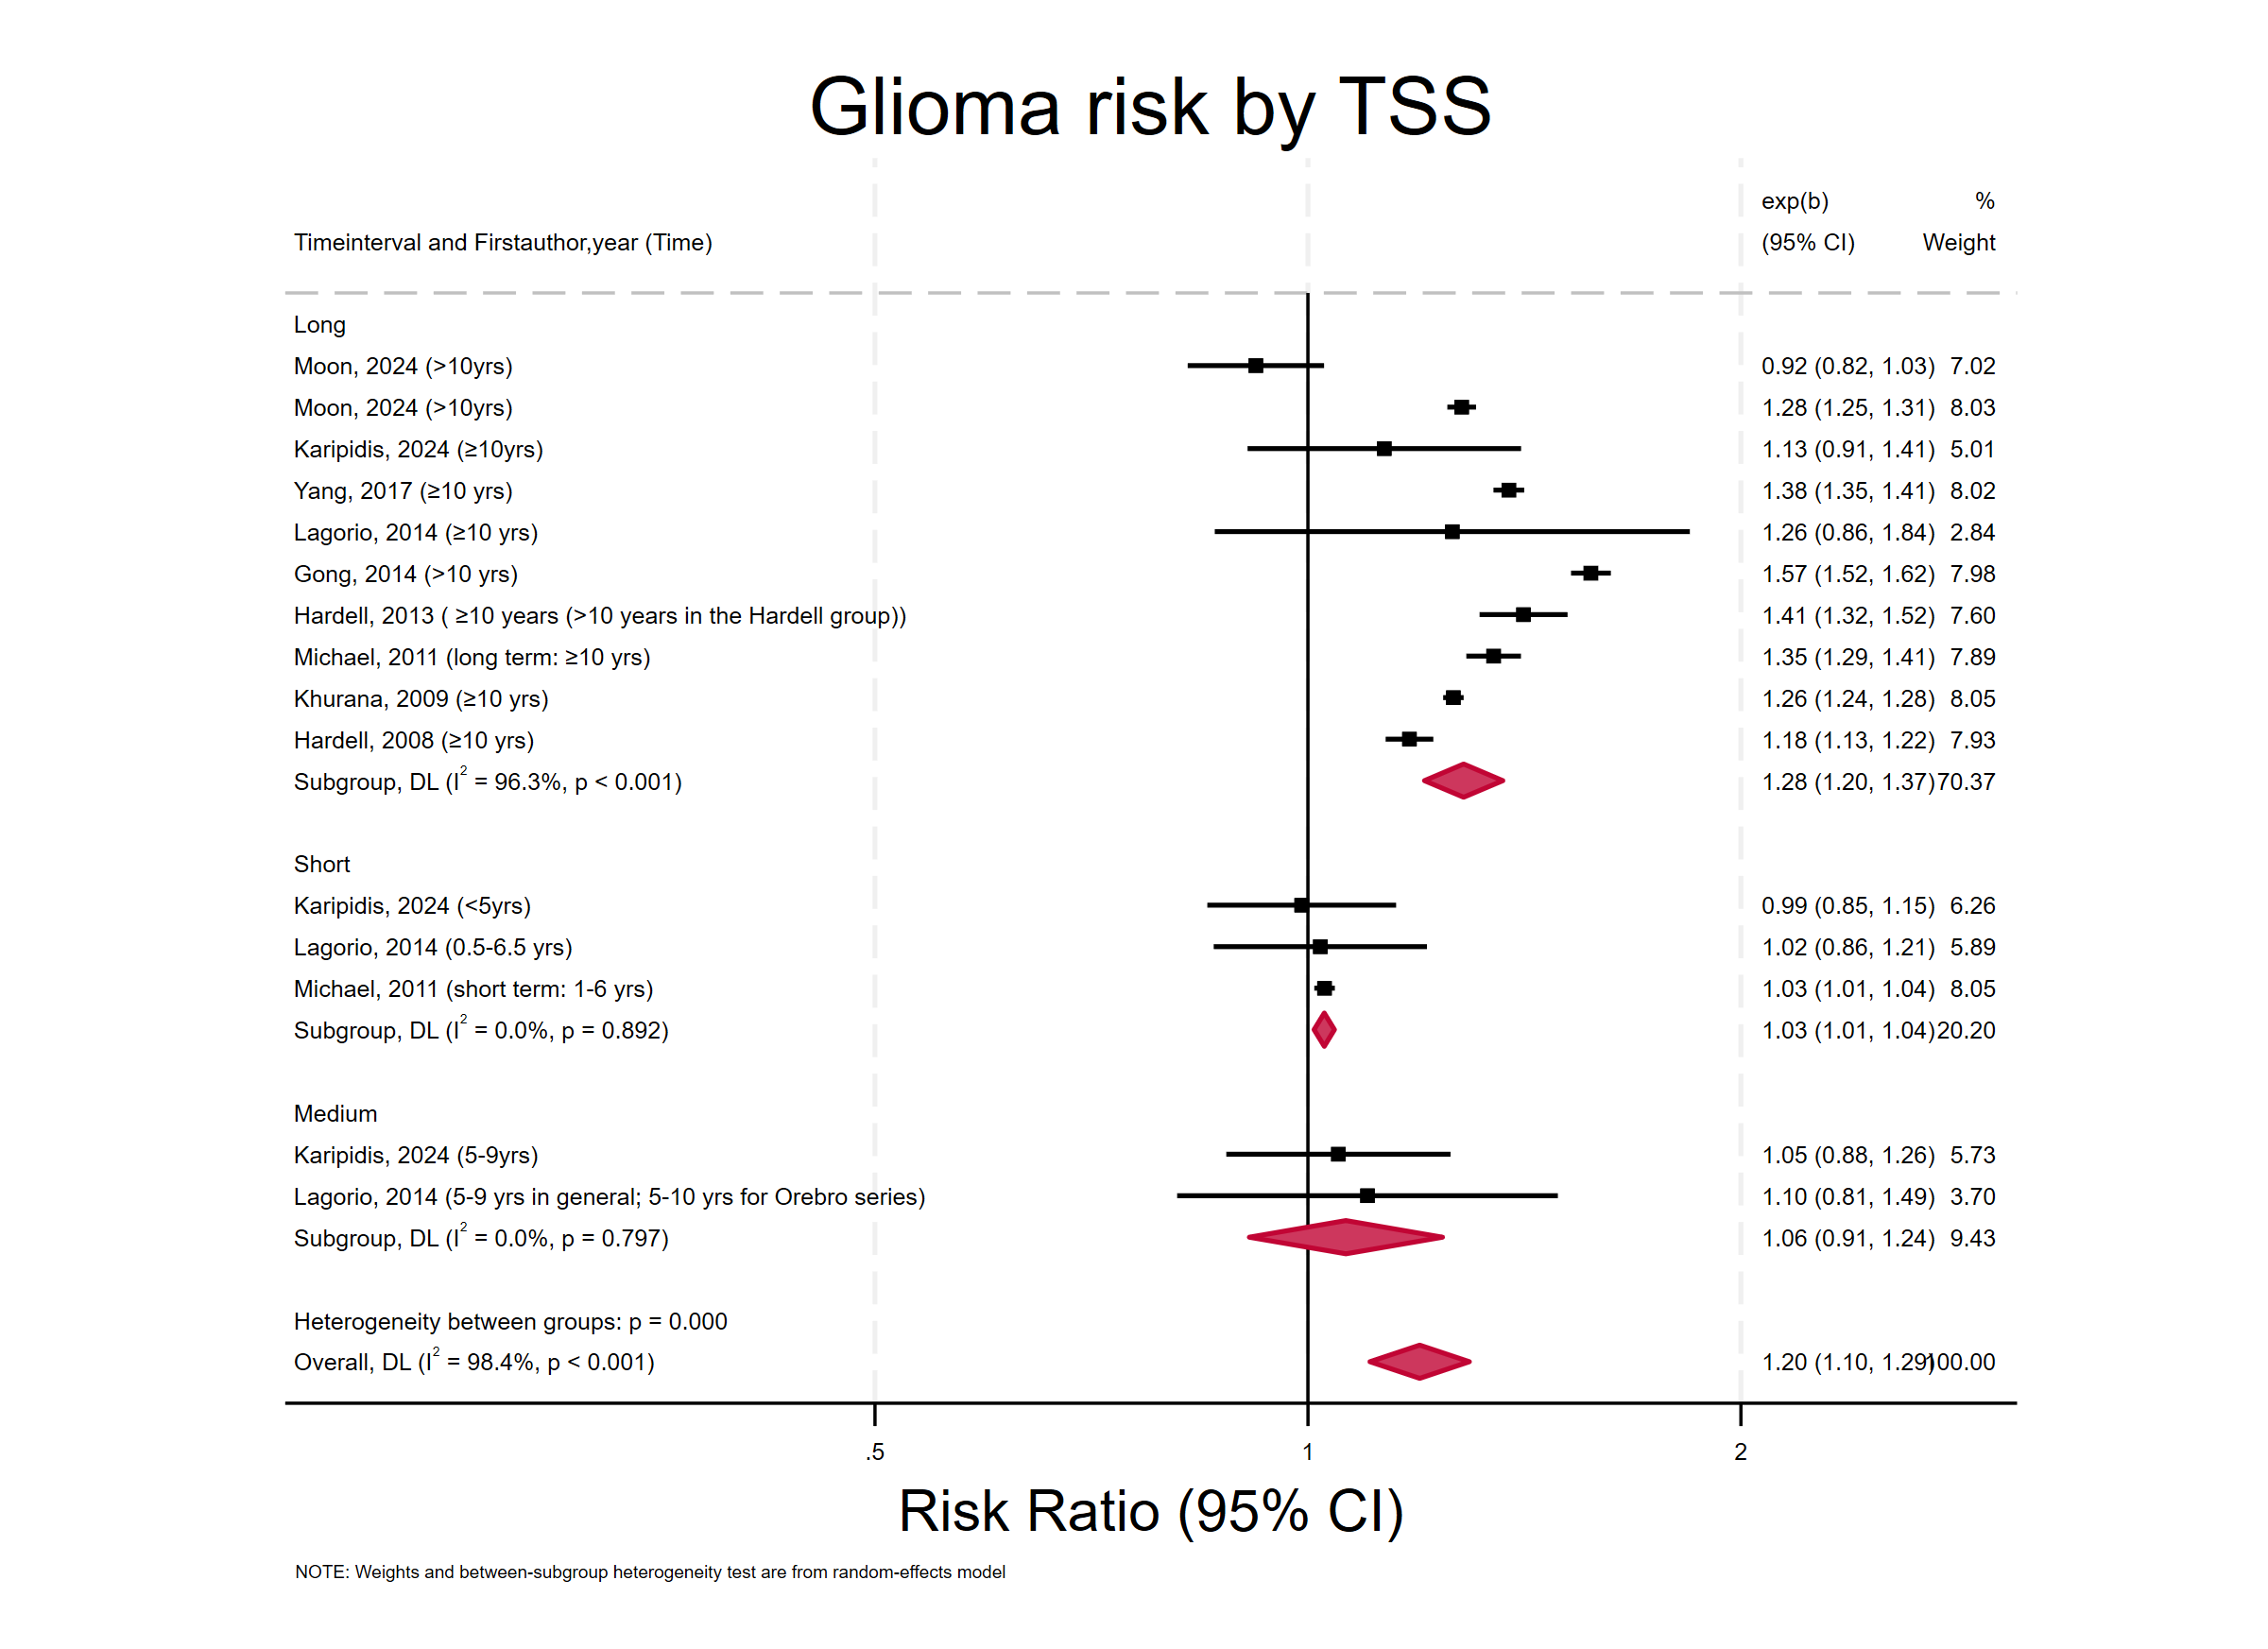
Supplementary Figure 27. Forest plot of the association between duration of mobile phone use and the risk of acoustic neuroma, expressed as RRs estimated using the delta method
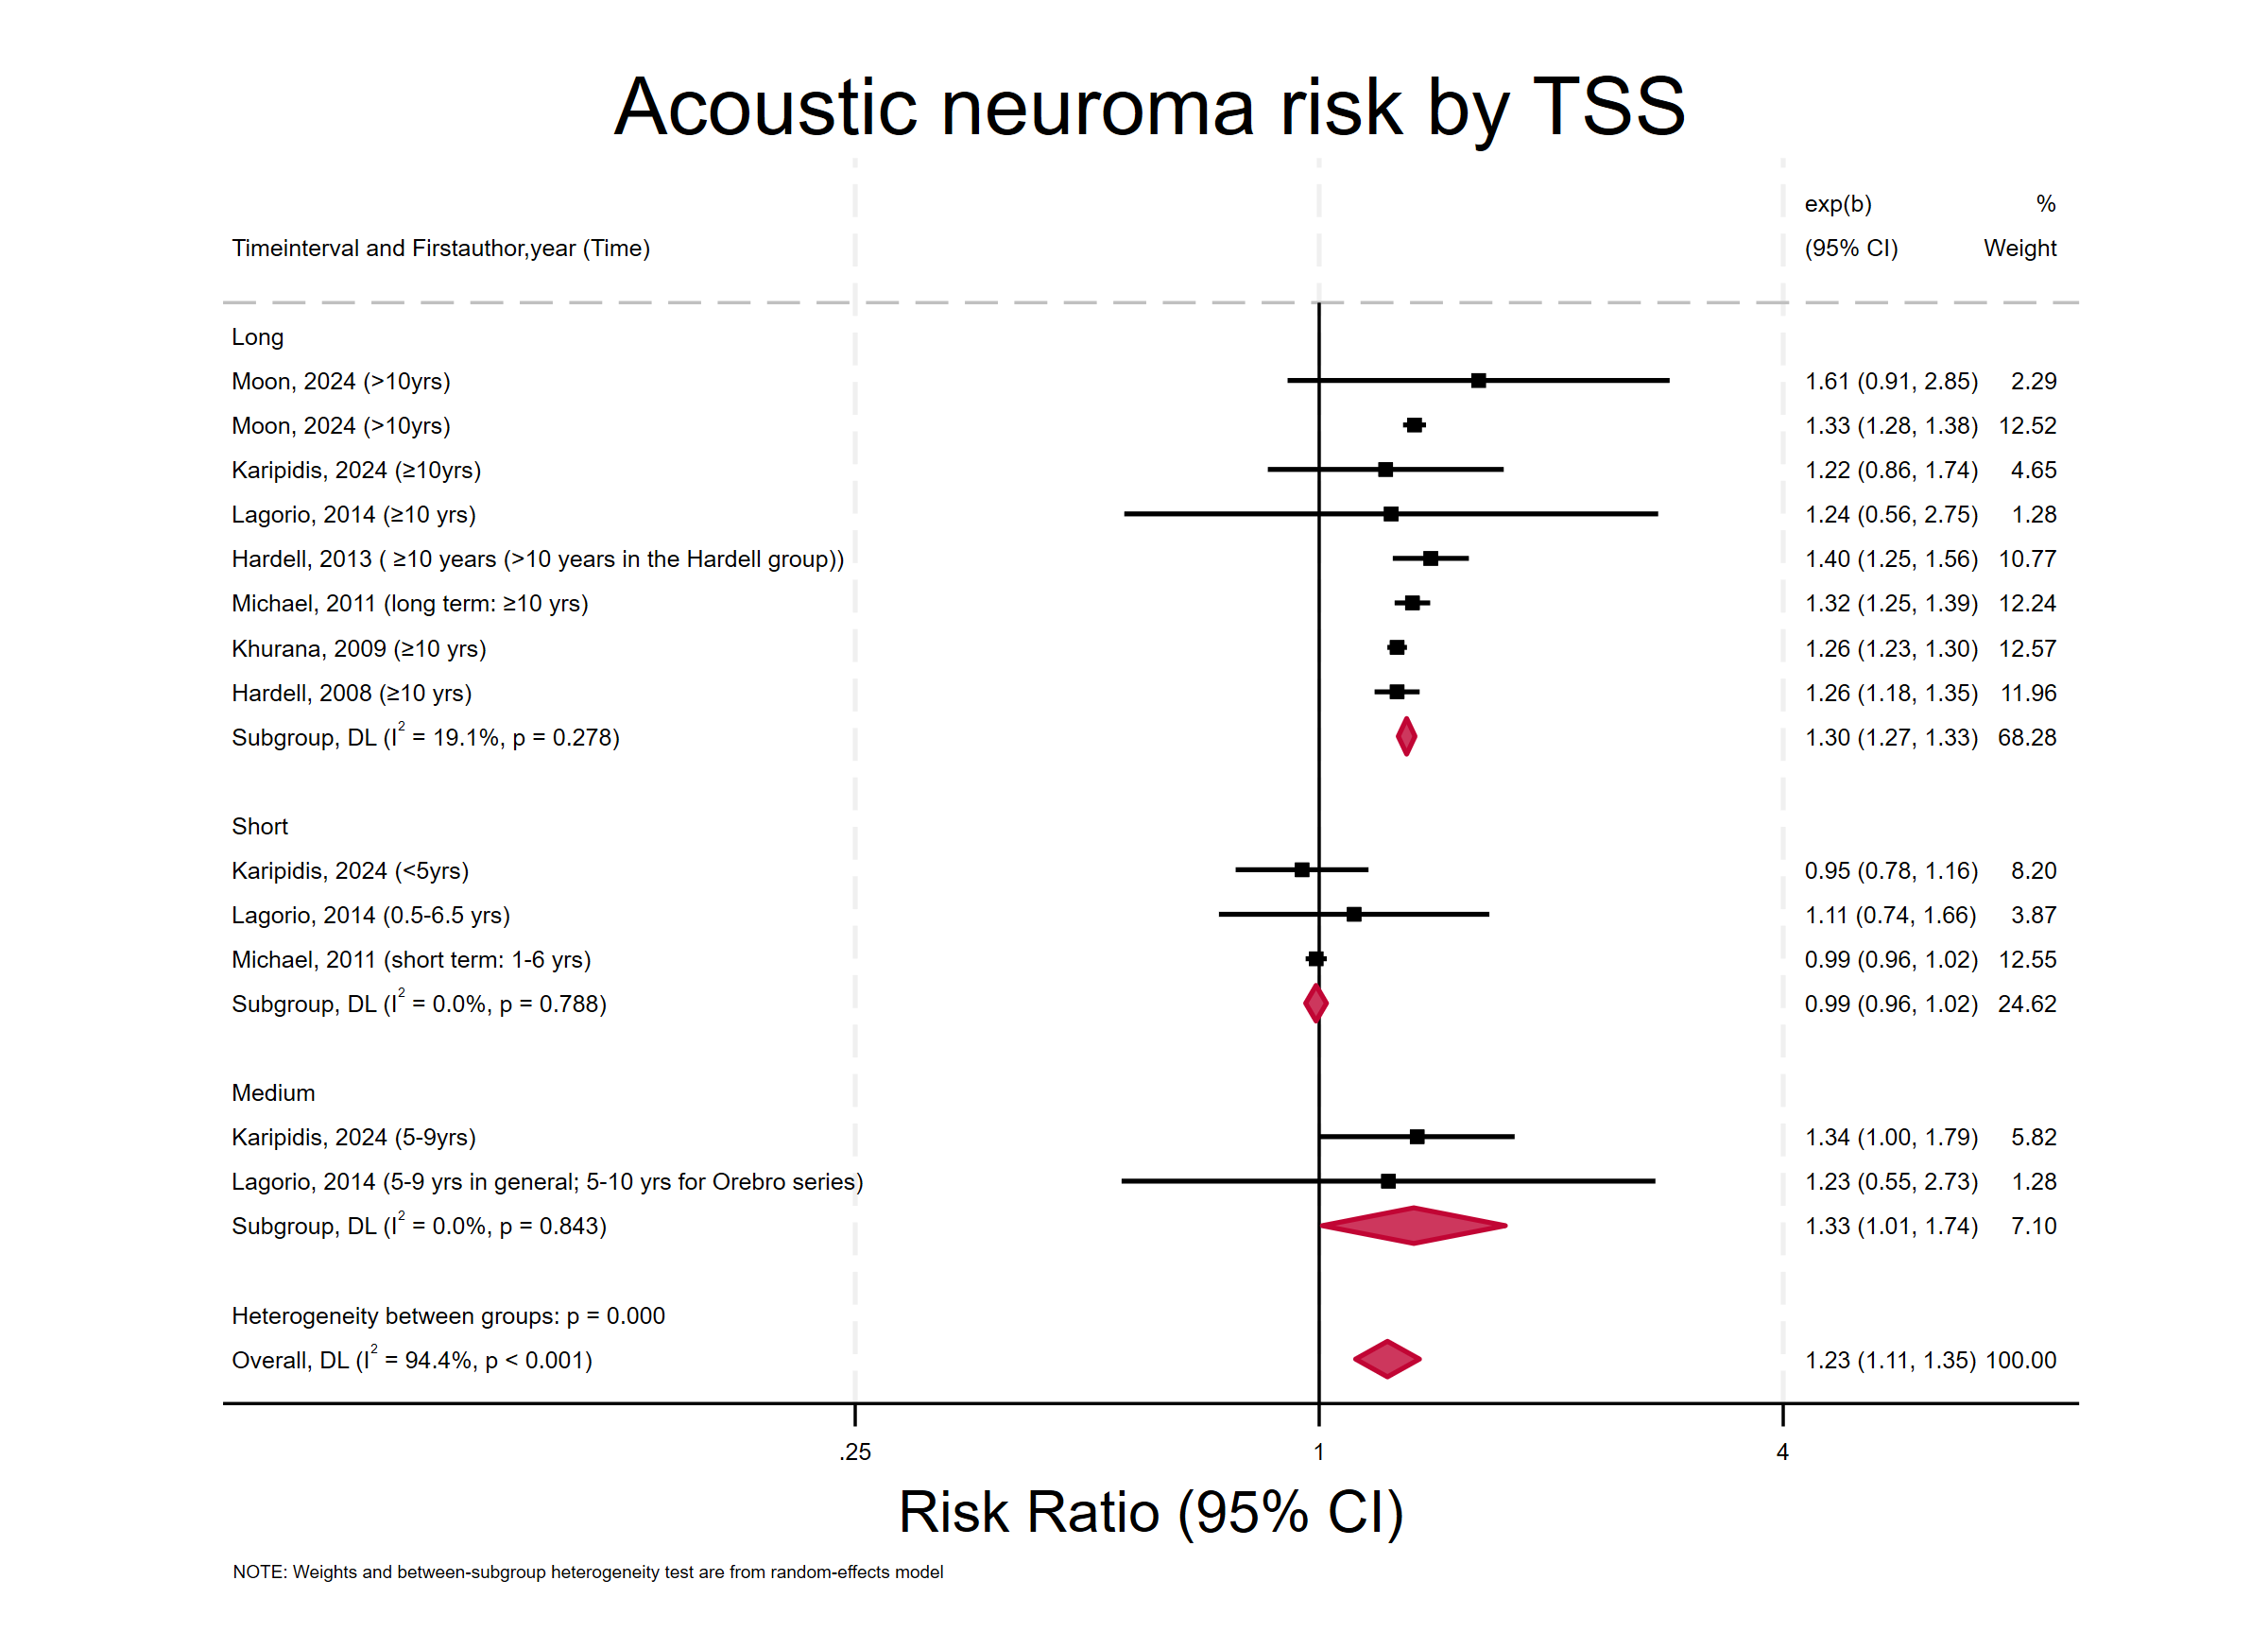
Supplementary Figure 28. Forest plot of the association between duration of mobile phone use and the risk of intracranial tumors, expressed as RRs estimated using the delta method
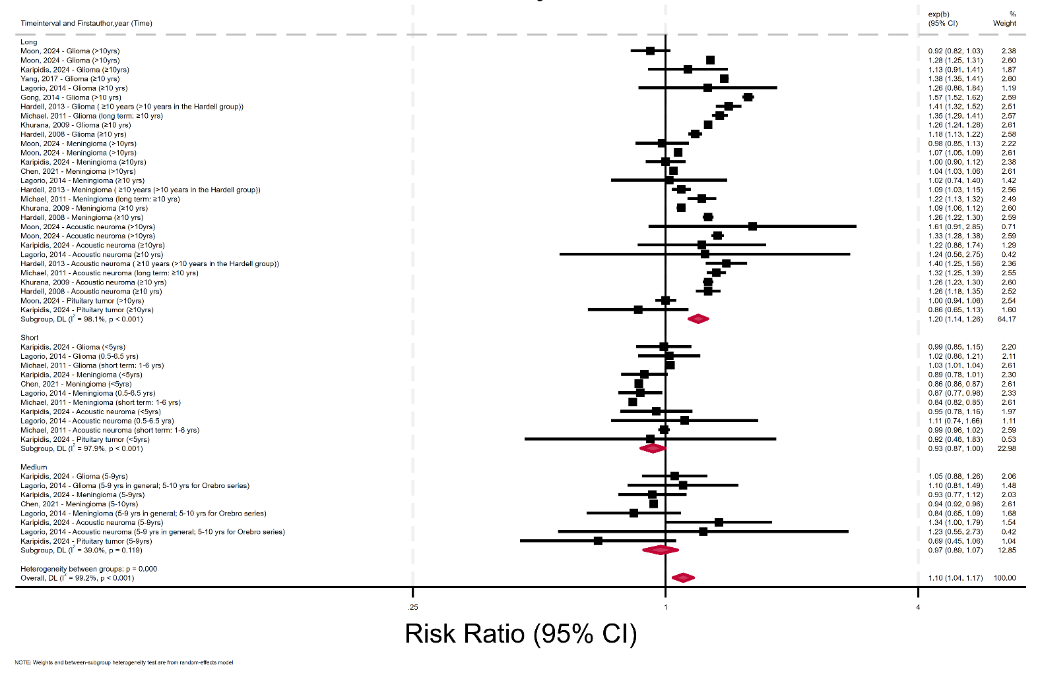
Supplementary Figure 29. Meta-regression analysis showing the association between exposure duration and RRs of meningioma
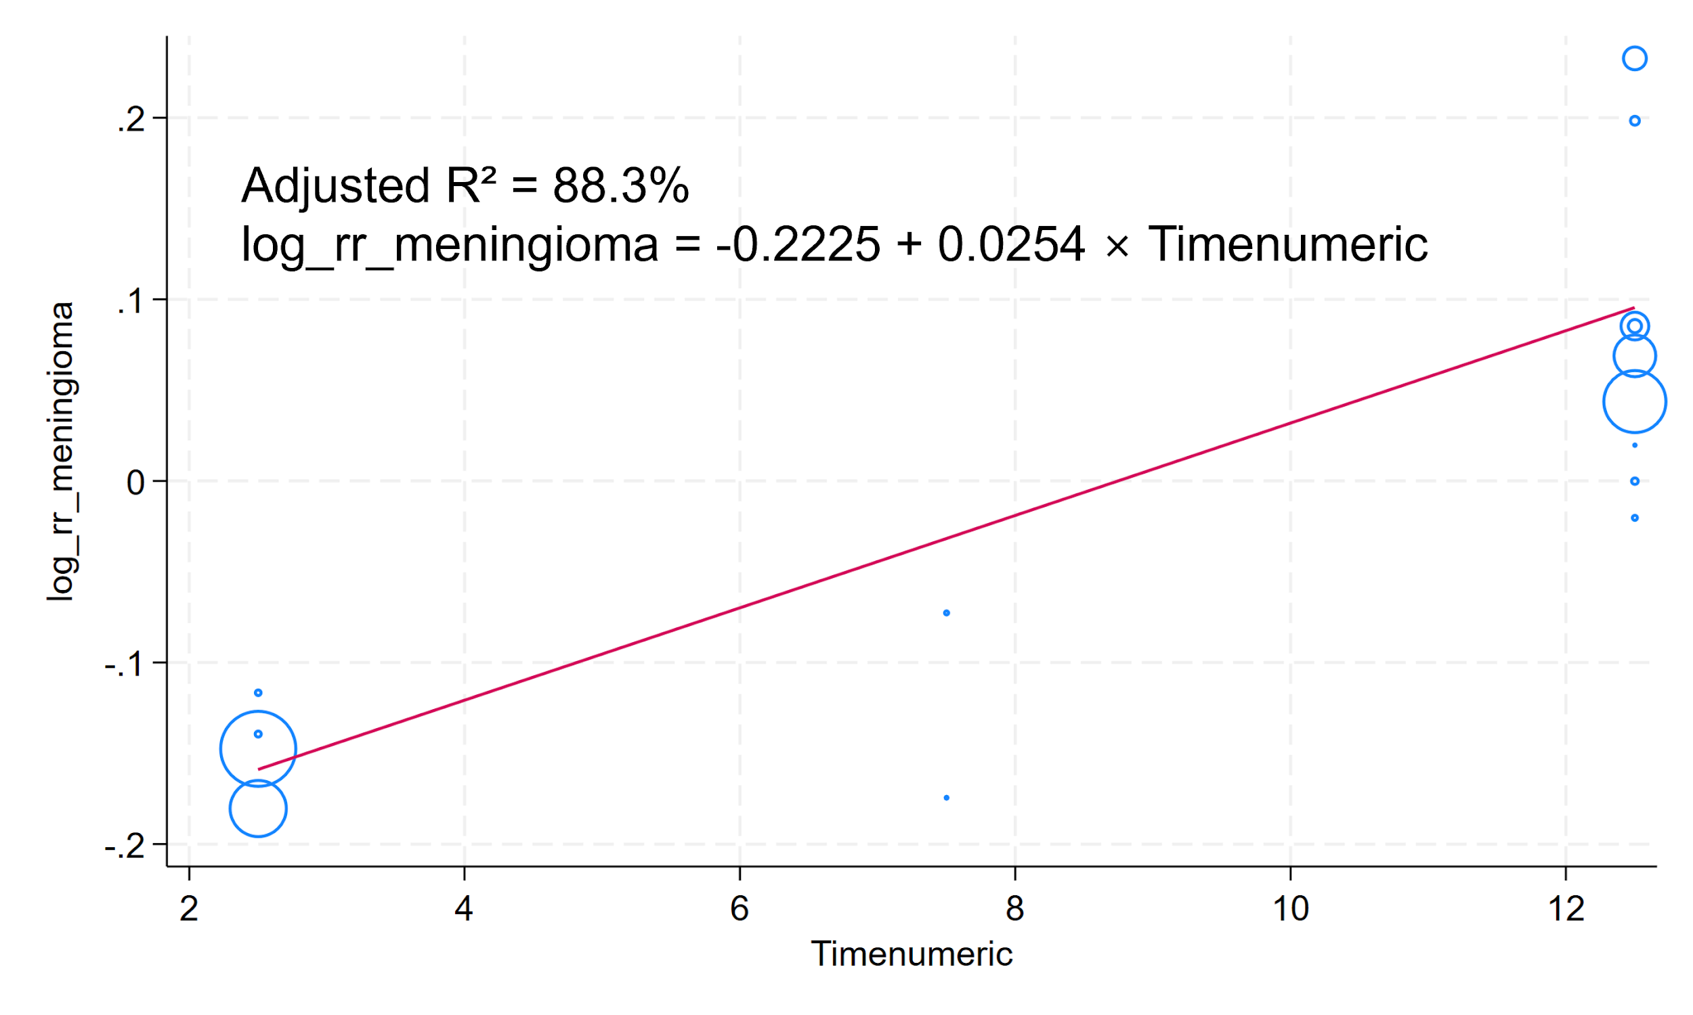
Supplementary Figure 30. Meta-regression analysis showing the association between exposure duration and RRs of glioma
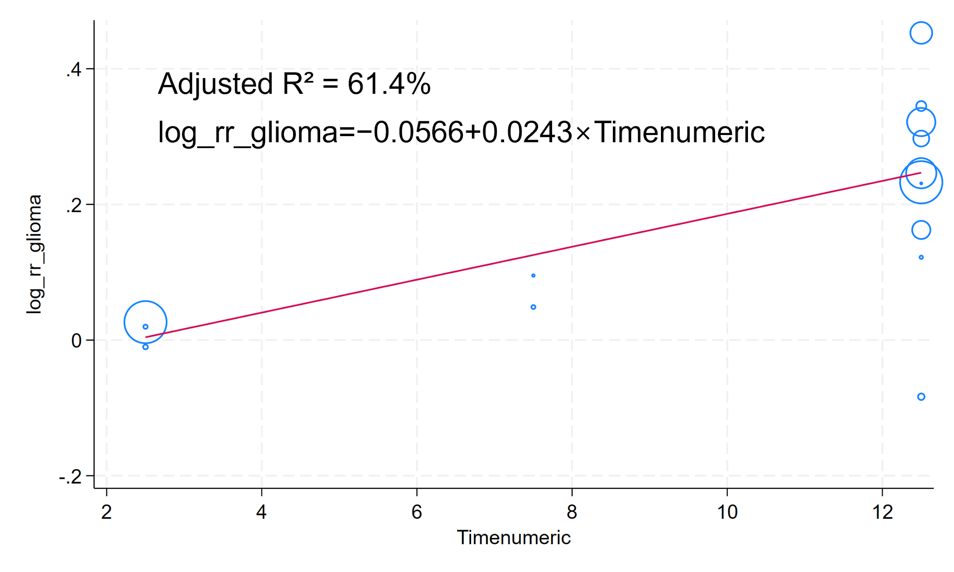
Supplementary Figure 31. Meta-regression analysis showing the association between exposure duration and RRs of acoustic neuroma
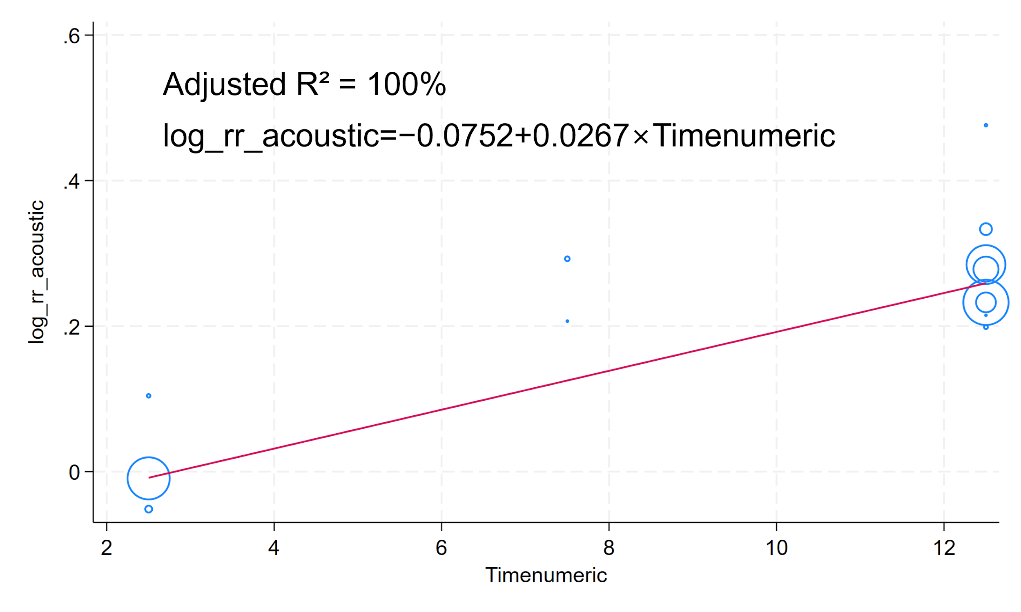
Supplementary Figure 32. Meta-regression analysis showing the association between exposure duration and RRs of intracranial tumors
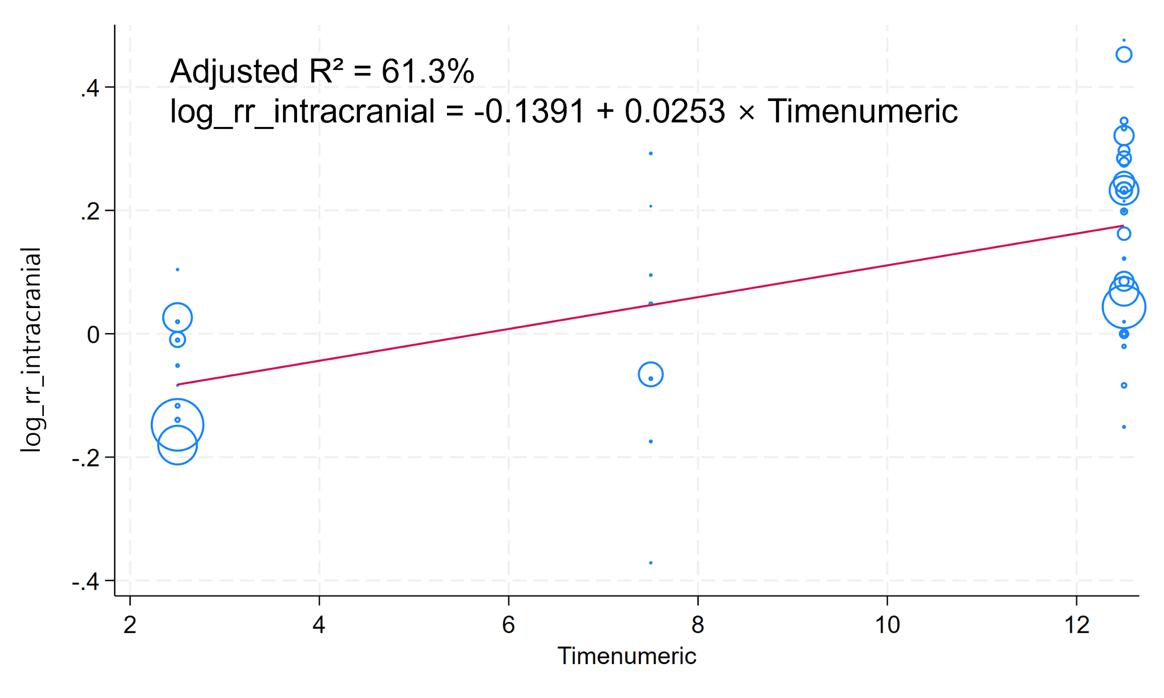
Supplementary Figure 33. Forest plot of the association between laterality of mobile phone use and risk of meningioma, expressed as ORs
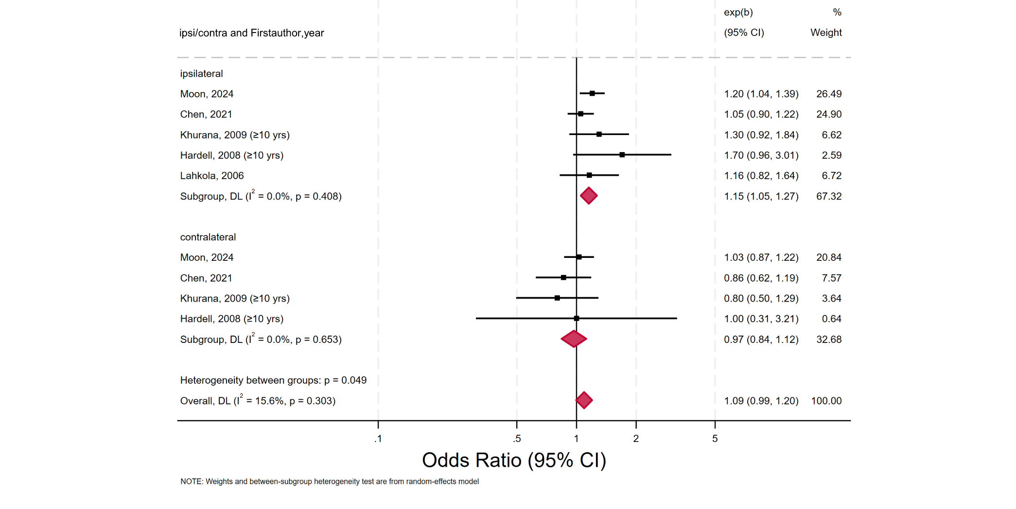

Supplementary Figure 34. Forest plot of the association between laterality of mobile phone use and glioma risk, expressed as ORs
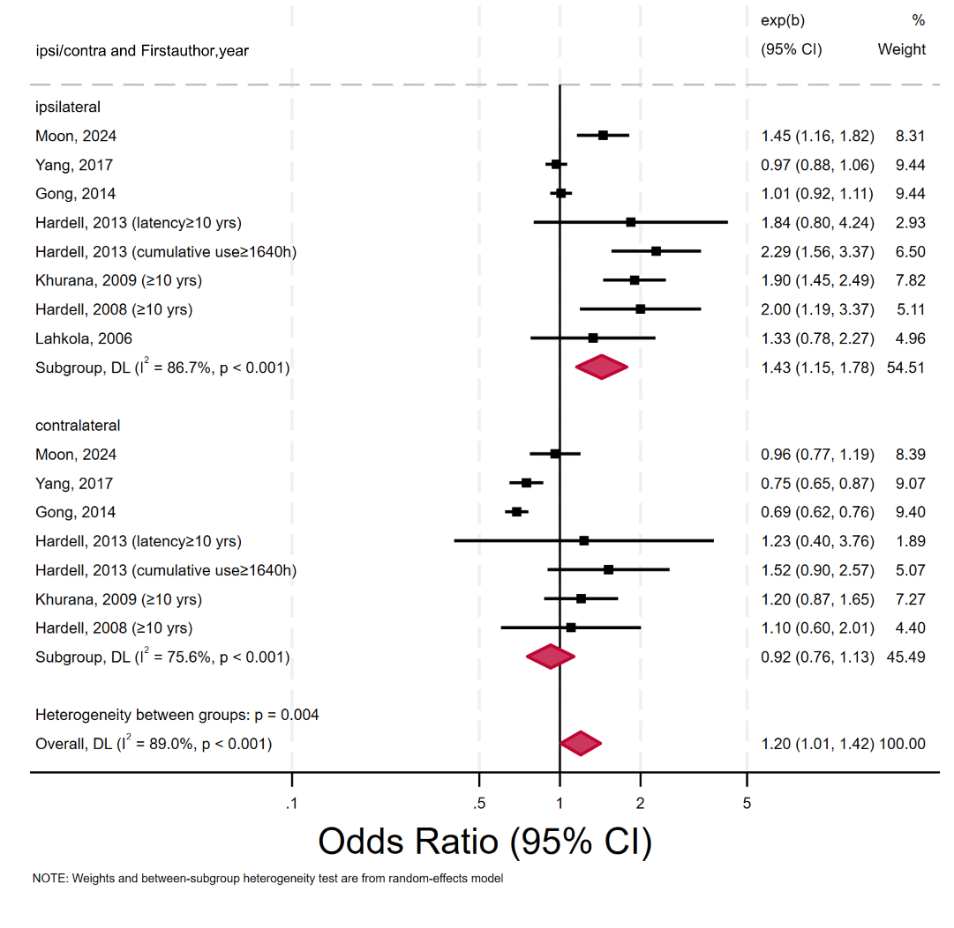

Supplementary Figure 35. Forest plot of the association between laterality of mobile phone use and risk of acoustic neuroma, expressed as ORs
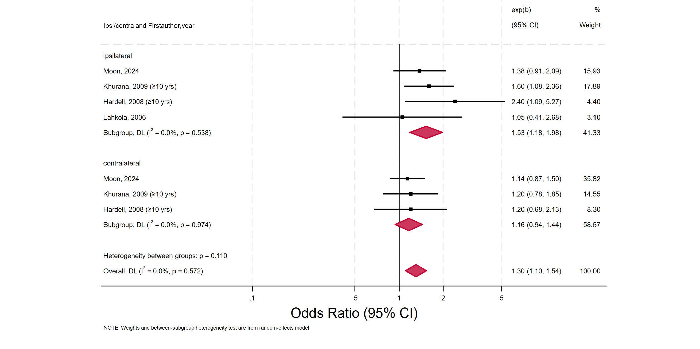
Supplementary Figure 36. Forest plot of the association between laterality of mobile phone use and risk of intracranial tumor, expressed as ORs
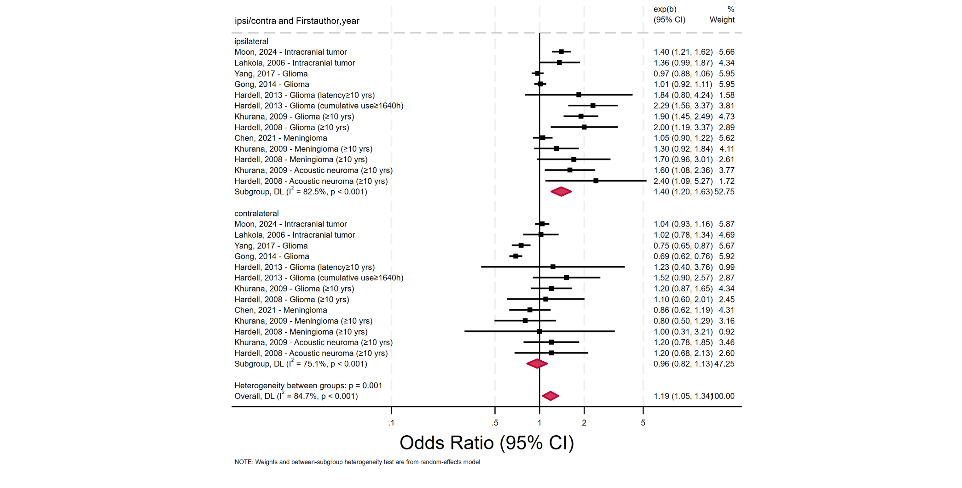
Supplementary Figure 37. Forest plot of the association between laterality of mobile phone use and risk of meningioma, expressed as ORs, restricted to studies rated as Moderate or High quality according to AMSTAR 2
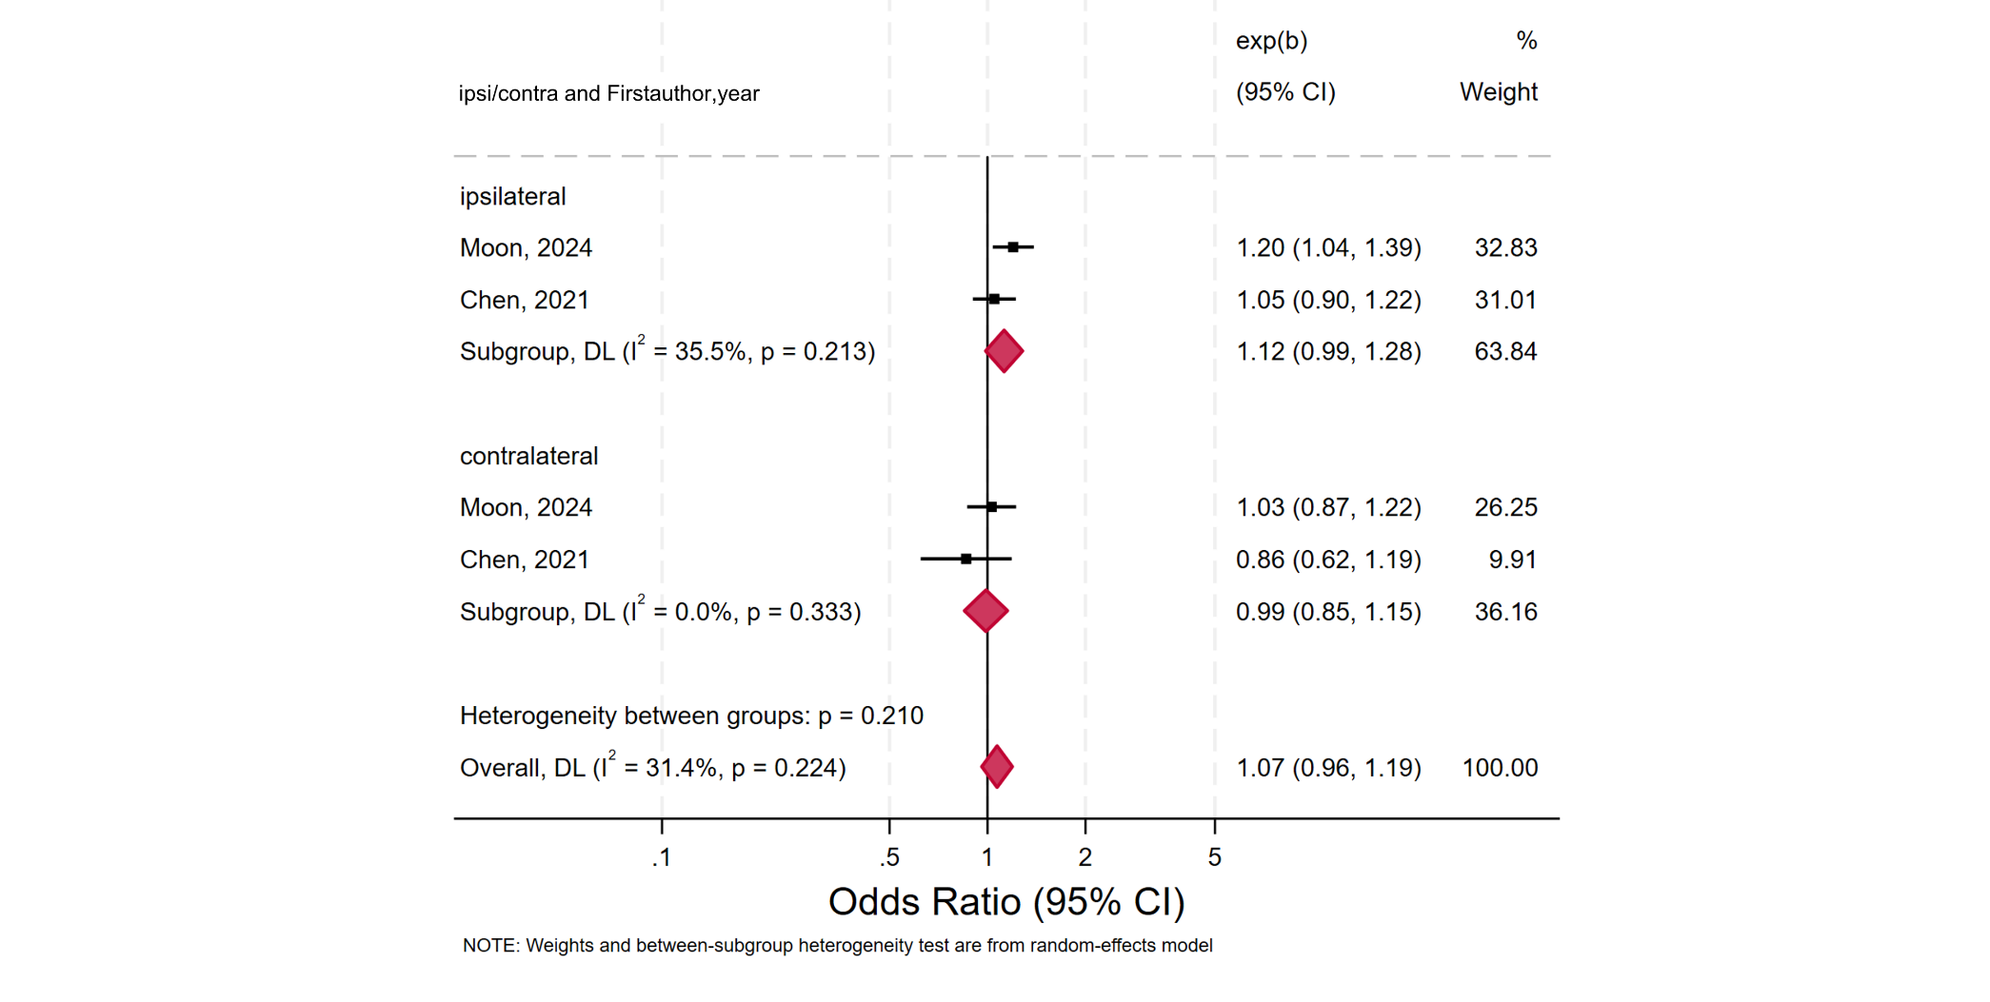
Supplementary Figure 38. Forest plot of the association between laterality of mobile phone use and risk of glioma, expressed as ORs, restricted to studies rated as Moderate or High quality according to AMSTAR 2
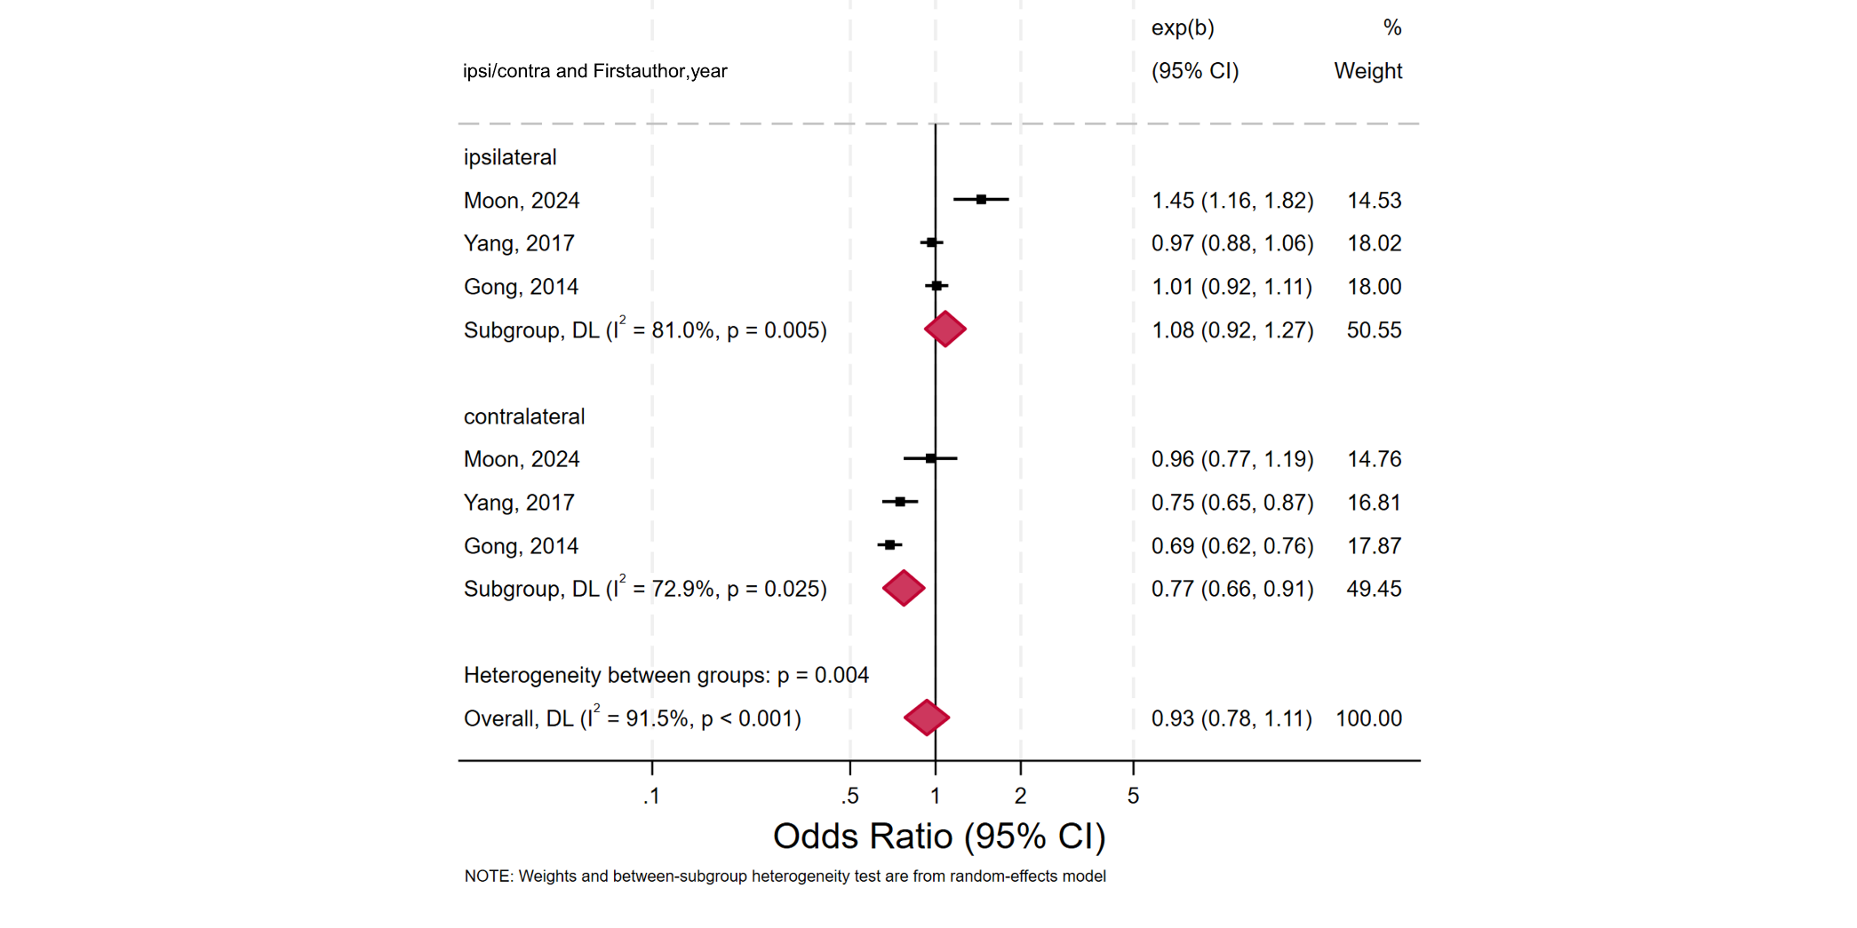
Supplementary Figure 39. Forest plot of the association between laterality of mobile phone use and risk of intracranial tumor, expressed as ORs, restricted to studies rated as Moderate or High quality according to AMSTAR 2
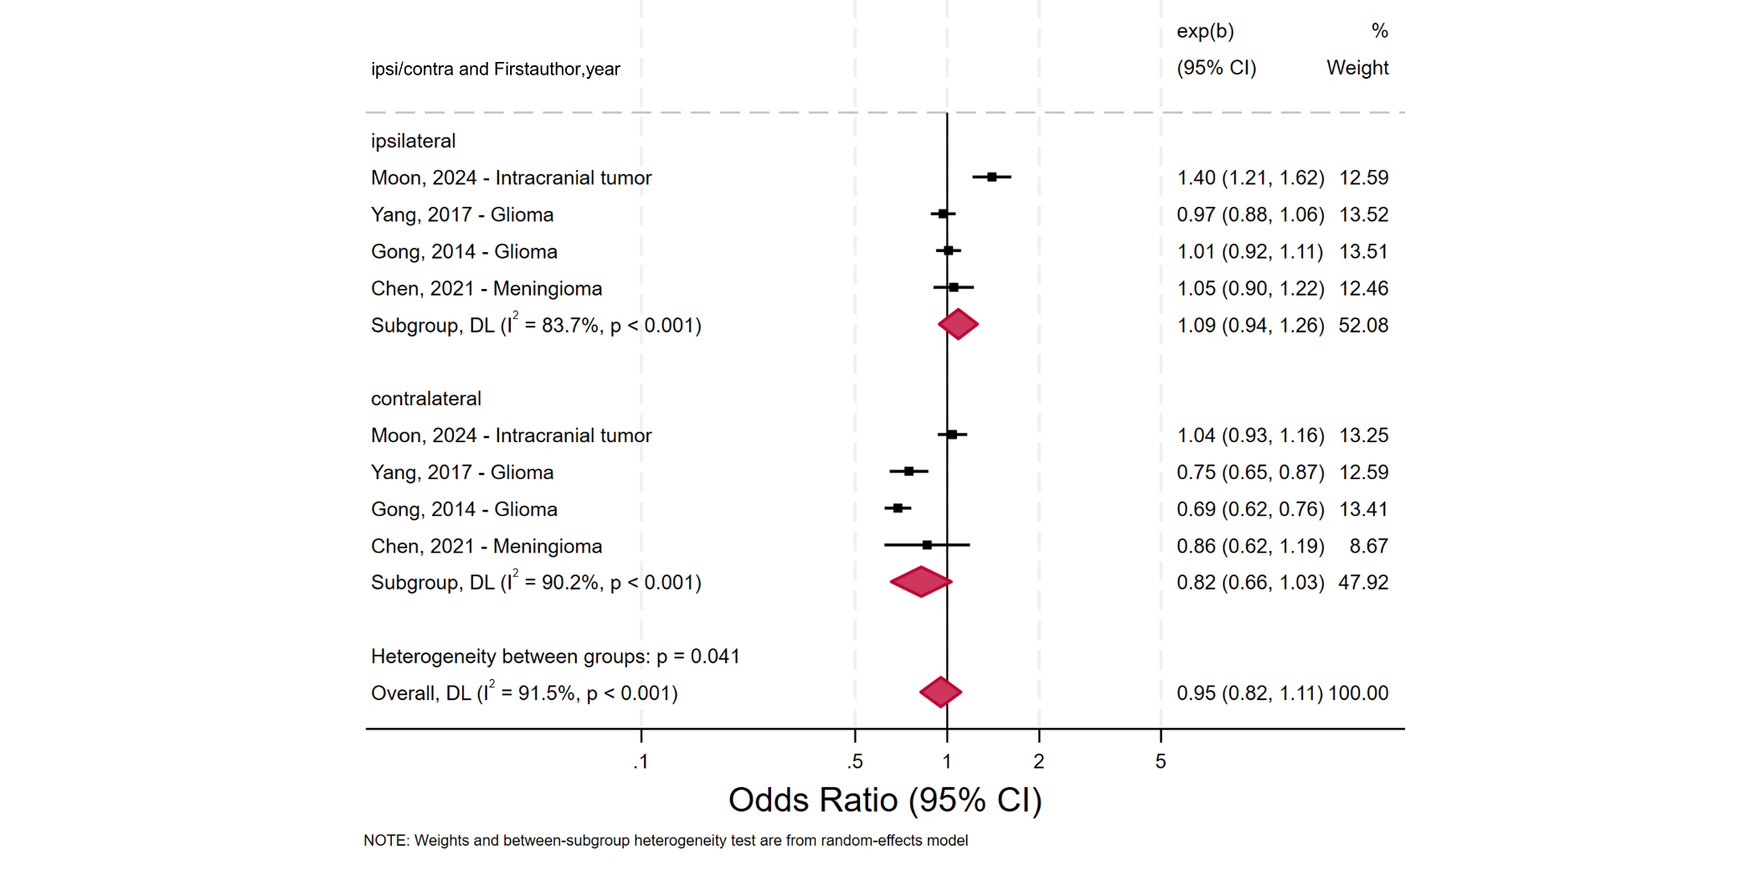
Supplementary Figure 40. Forest plot of the association between laterality of mobile phone use and meningioma risk excluding long-term users, expressed as ORs
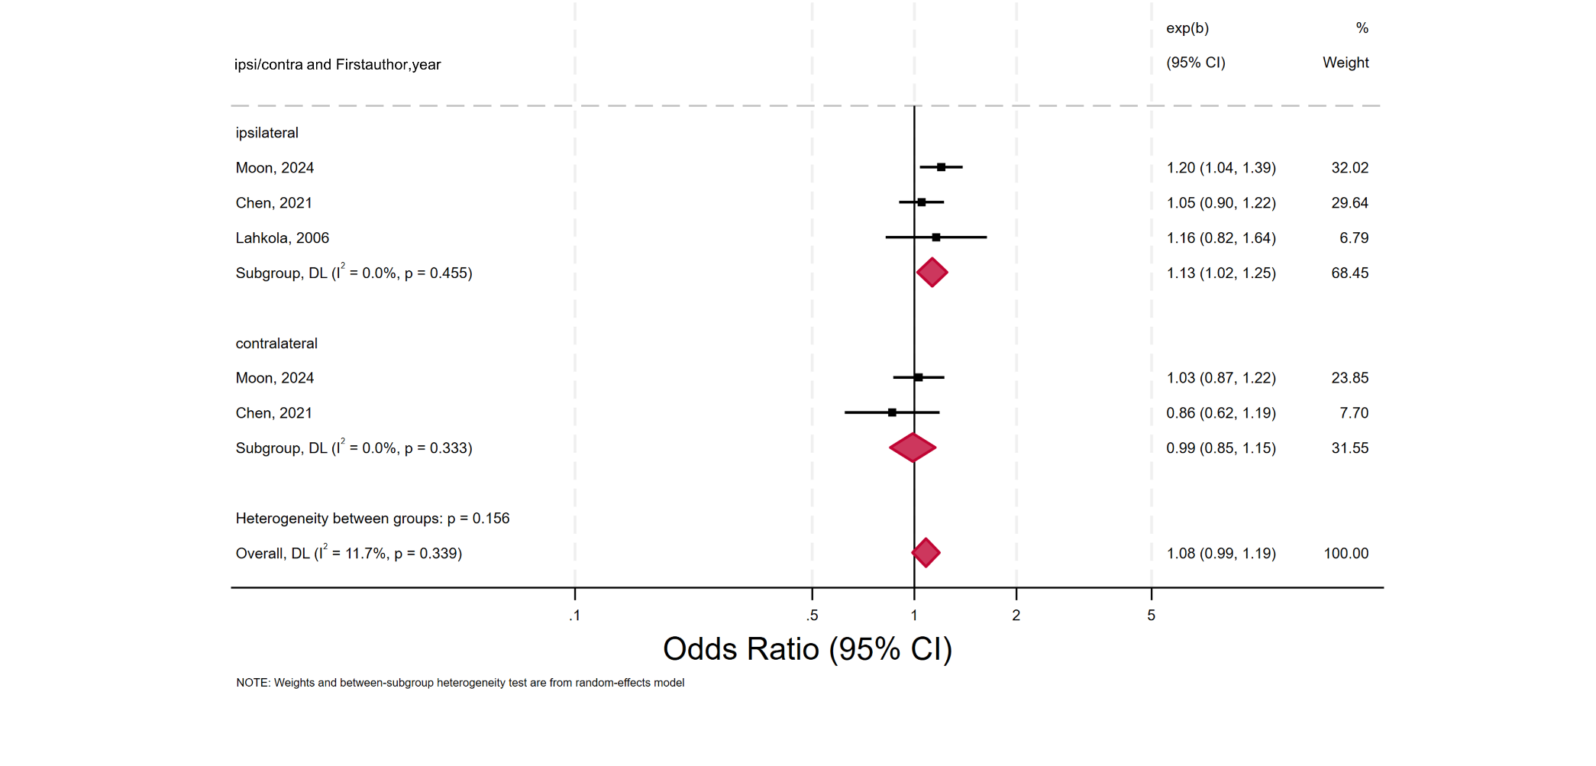

Supplementary Figure 41. Forest plot of the association between laterality of mobile phone use and glioma risk excluding long-term users, expressed as ORs
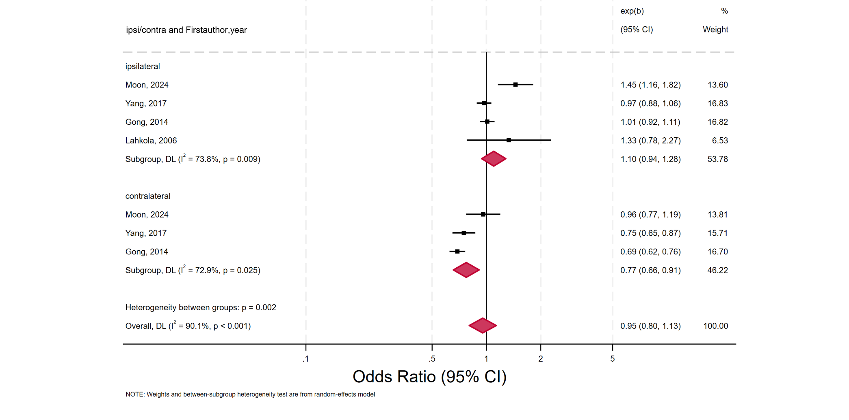
Supplementary Figure 42. Forest plot of the association between laterality of mobile phone use and acoustic neuroma risk excluding long-term users, expressed as ORs
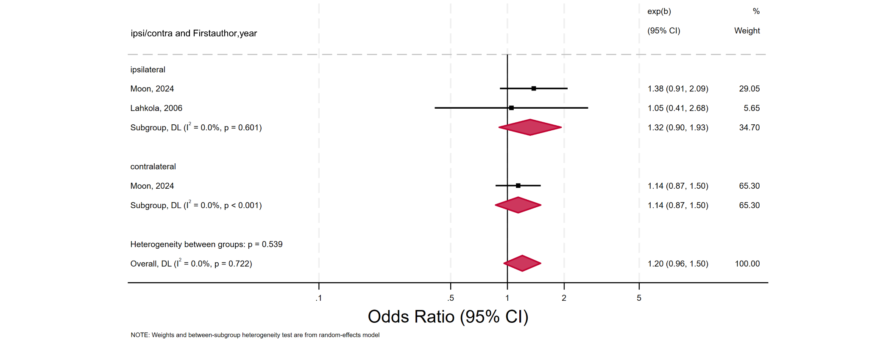

Supplementary Figure 43. Forest plot of the association between laterality of mobile phone use and intracranial tumor risk excluding long-term users, expressed as ORs
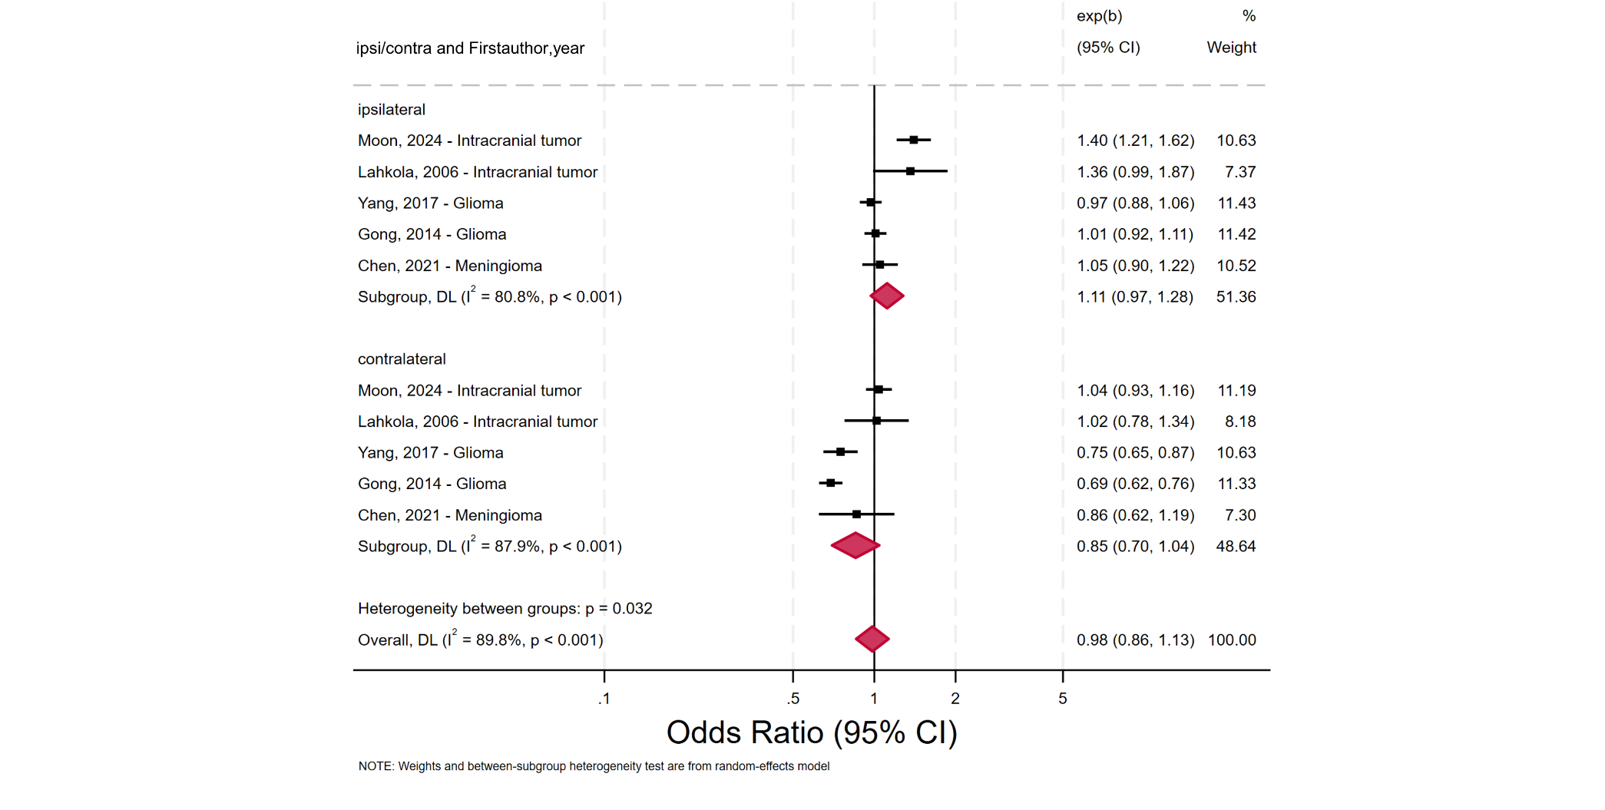
Supplementary Figure 44. Forest plot of the association between laterality of mobile phone use and meningioma risk among long-term users, expressed as ORs
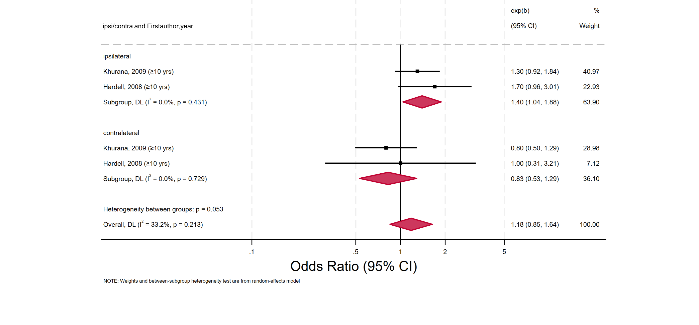

Supplementary Figure 45. Forest plot of the association between laterality of mobile phone use and glioma risk among long-term users, expressed as ORs
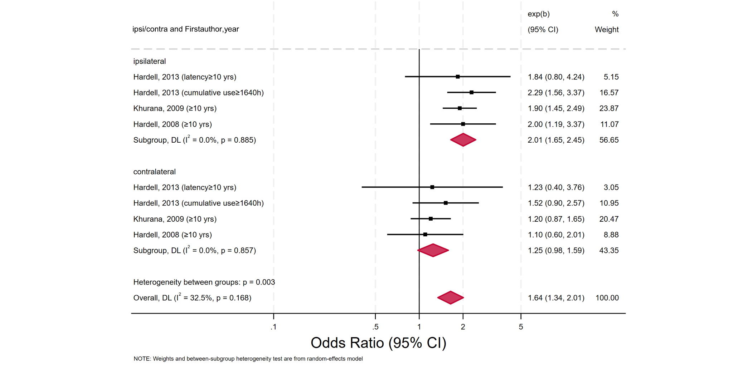
Supplementary Figure 46. Forest plot of the association between laterality of mobile phone use and acoustic neuroma risk among long-term users, expressed as ORs
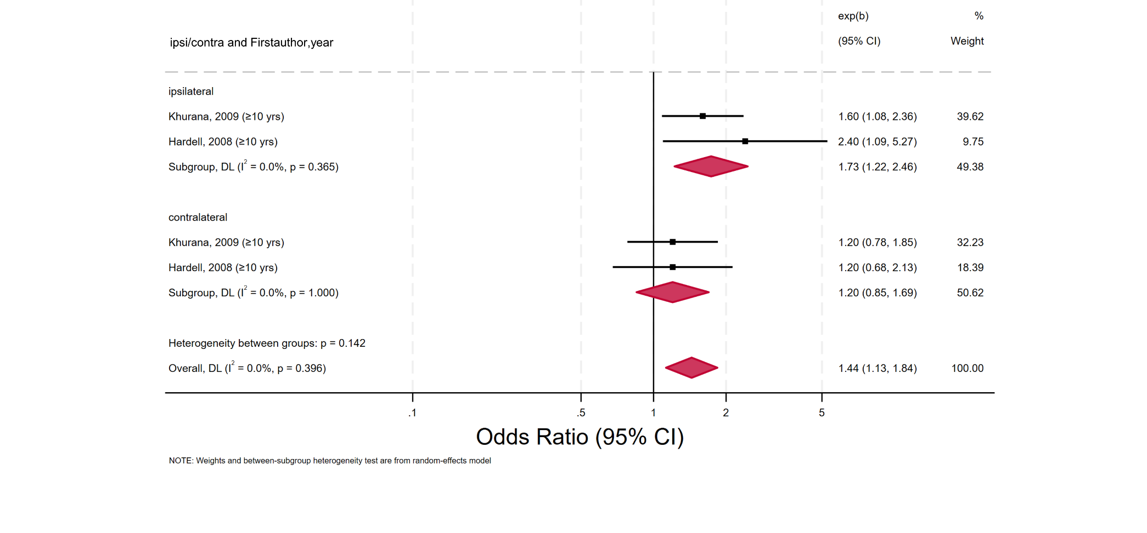

Supplementary Figure 47. Forest plot of the association between laterality of mobile phone use and intracranial tumor risk among long-term users, expressed as ORs
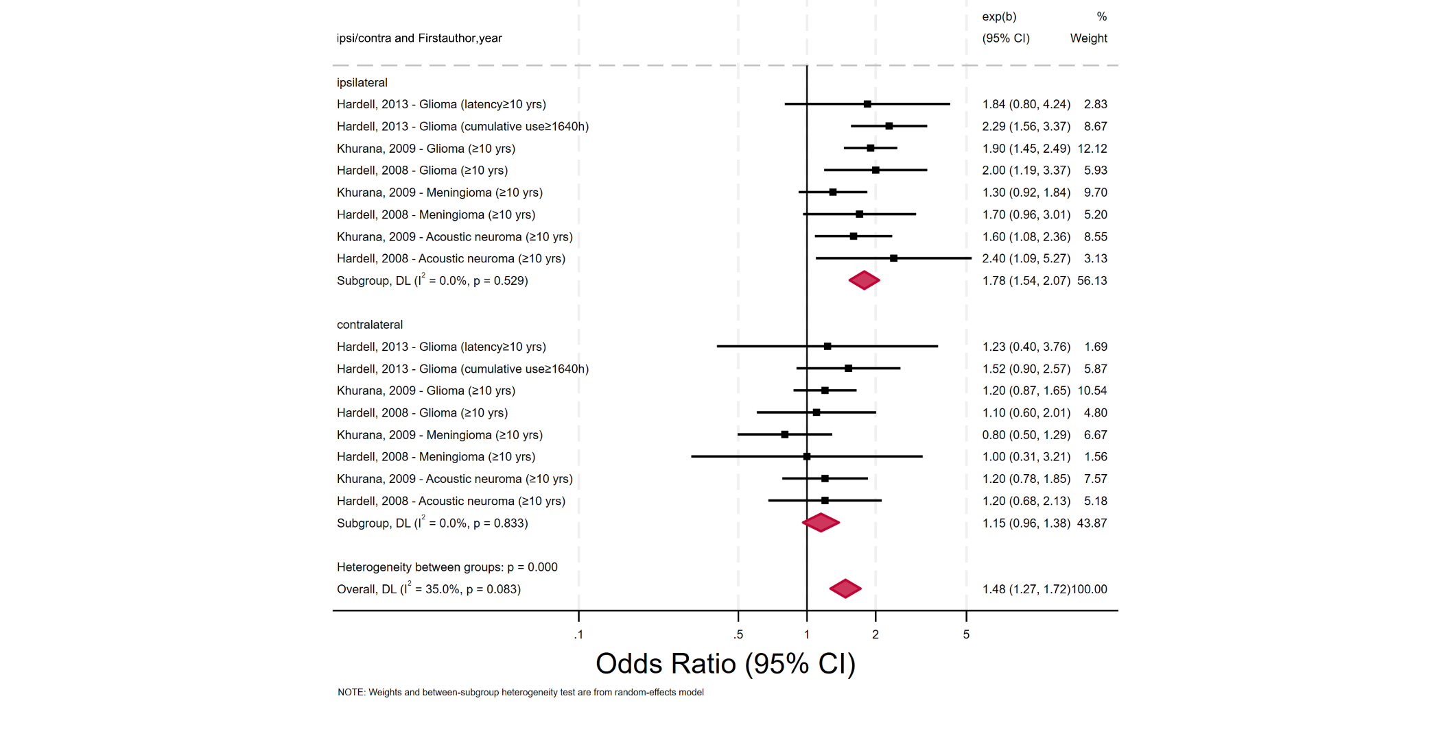
Supplementary Figure 48. Funnel plot assessing small-study effects for intracranial tumor risk based on ORs
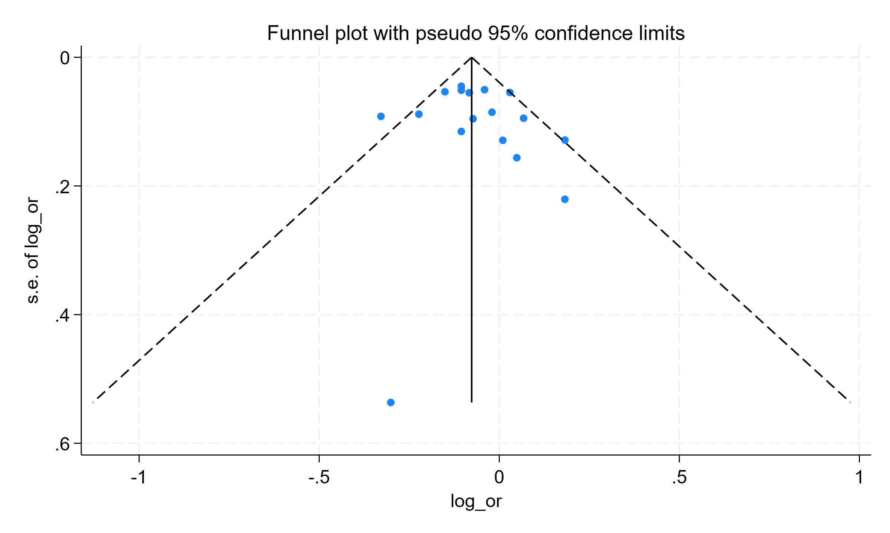

Supplementary Figure 49. Funnel plot assessing small-study effects for intracranial tumor risk based on RRs
